GreenLawAI: Forestry and Climate Awareness System



Session (2022-2026)
Program:
Bachelor of Studies in Computer Science
Submitted by:
Hina Ali Farooq (COMSC-F22-014)
Eeman (COMSC-F22-024)
Supervised by:
Mr. Mujahid Younis
Lecturer, Department of Computer Science

DEPARTMENT OF COMPUTER SCIENCE

GOVT. POSTGRADUATE COLLEGE MANSEHRA, HED, KP
GreenLawAI: Forestry and Climate Awareness System

A report submitted to
Department of Computer Science
Government Postgraduate College Mansehra, HED, KP
As partial fulfillment of requirements
For the award of the degree of
Bachelor of Computer Science

DEPARTMENT OF COMPUTER SCIENCE
GOVT. POSTGRADUATE COLLEGE MANSEHRA, HED, KP
FINAL APPROVAL
This is to certify that we have read the thesis titled “GreenLawAI: Forestry and Climate Awareness System” submitted by the following students of Bachelor of Studies in Computer Science (2022-2026) of Govt. Postgraduate College, Mansehra.
Student Name | Registration No.
hina ali farooq  Eeman | 22-MSR-BS-93  22-MSR-BS-103

We judged that this thesis is of sufficient standard to warrant its acceptance by the Department of Computer Science Govt Postgraduate College, Mansehra for the award of Bachelor of Studies (BSCS) degree in Computer Science from Hazara University, Mansehra.
External Examiner Signature:
External Examiner Name: | Dr. Syed Hamad Shirazi
Designation & Institute: | Assistant Professor Computer Science,  Hazara University Mansehra
Internal Examiner Signature:
Internal Examiner Name: | Mr. Junaid Hussain
Designation & Institute: | Lecturer Computer Science, GPGC Mansehra
Supervisor Signature:
Supervisor Name: | Mr. Mujahid Younis
Designation & Institute: | Lecturer Computer Science, GPGC Mansehra
Head of Department Signature:
Head of Department Name: | Mr. Muhammad Abid
Designation & Institute: | Assistant Professor Computer Science, GPGC Mansehra

DEDICATION
Dedicated to the preservation of forests, crucial for preventing the loss of biodiversity, managing air and water quality, and mitigating climate change. To the woodlands that give us oxygen, shelter wildlife, and hold our planet together in ways we often take for granted. To the goal of bridging the gap between complex forestry policies and real-world understanding, so that laws meant to protect become clear, accessible, and truly useful for those who need them most. To everyone who believes that awareness leads to action, and that sustainable choices today will determine the world we leave behind.

DECLARATION
We solemnly declare that the work presented in this thesis titled
" GreenLawAI: Forestry and Climate Awareness System" is our original effort and has not been copied or plagiarized from any source. This research was conducted with sincere academic integrity.
All the data, figures, and results presented in this thesis are genuine and based on actual implementation. Any material taken from other sources has been properly cited and acknowledged.
We understand the significance of academic honesty and take full responsibility for the authenticity and originality of this work. We are aware that any violation of academic rules or instances of plagiarism can lead to disciplinary action by the institution.

Name: Signature:
- Hina Ali Farooq ________________________
- Eeman ________________________

ACKNOWLEDGEMENT
In the name of Allah, the Most Gracious, the Most Merciful.
All praise and gratitude are due to Almighty Allah, whose infinite mercy, blessings, and guidance enabled us to successfully complete this research project. His wisdom and strength gave us the determination to overcome the challenges encountered throughout this work.
We express our sincere appreciation to our respected supervisor, Mr. Mujahid Younis, for his continuous guidance, valuable insights and constructive feedback throughout the project’s research process.
We are also thankful to Mr. Junaid Hussain for his invaluable assistance and intellectual contributions during the initial conceptualization and finalization of this project idea. His guidance helped refine our approach and strengthened the foundation of this project.
We also acknowledge Government Postgraduate College Mansehra for providing us with the opportunity, academic resources, and facilities necessary to carry out this research successfully.
Hina Ali Farooq(COMSC-F22-014)
Eeman(COMSC-F22-024)

PROJECT IN BRIEF

Project Title | GreenLawAI: Forestry and Climate Awareness System
Organization | Government Postgraduate College Mansehra
Undertaken By | Hina Ali Farooq & Eman
Supervised By | Mr. Mujahid Younis, Lecturer Computer Science
Starting Month | October 2025
Ending Month | July 2026
Software Used | Python, Visual Studio Code, Git, Neo4j, FAISS,
Environment Used | Windows 10, Web Browser (Chrome)
System Used | HP Pavilion Laptop (Intel Core i3)

PREFACE
This report presents a detailed study, design, and implementation of the project titled "GreenLawAI: Forestry and Climate Awareness System" To make the report easy to understand and follow, it has been divided into structured:
Chapter 1: Introduction
This chapter introduces GreenLawAI, a smart chatbot enhanced with Agentic AI capabilities designed to simplify forestry regulations and provide clear, reliable guidance. It defines the core problem of high-level situational blindness and establishes the project's aim: to make legal and environmental knowledge simple, reliable, and accessible for everyone. The chapter outlines the project's primary objectives, which include building a well-structured knowledge base of official forestry data and integrating agentic components that proactively detect patterns of illegal activities.
Chapter 2: Existing Systems and Literature Review
Chapter 2 reviews the current landscape of AI in environmental management, identifying specialized forestry assistants such as Finn by SilviaTerra, Forestry Advisor, and ForestChat. This review reveals a critical gap: the absence of systems that make forestry laws understandable and jurisdiction-specific. The chapter further benchmarks established research, such as the ForestNet model for classifying deforestation drivers and the Tree-GPT framework for modular expert systems in forest remote sensing.
Chapter 3: Methodology and System Architecture
This chapter details the 5-Layer Reactive Decoupled Architecture of GreenLawAI, which effectively separates high-latency reasoning from real-time data ingestion. It elaborates on the hybrid retrieval strategy that merges semantic vector search via FAISS with the relational structural walk of a Neo4j knowledge graph to achieve high-fidelity legal grounding. The methodology is grounded in mathematical formulations, such as the Haversine formula for spherical spatial clustering and the Carbon Risk Sequestration model for estimating ecological damage.

Chapter 4: Implementation and Technical Deep Dive
Chapter 4 provides a production-level architectural breakdown of the system’s implementation through a unified portal located at portal.py. It profiles the multi-agent system (MAS), detailing the technical roles of agents like the LawAgent for statutory reasoning and the ClimateAgent for tactical environmental risk modeling. The chapter also describes the plan-driven ReAct loop within the AgenticCoordinator and the background dispatch loop managed by the ForestWatchdog service.
Chapter 5: Evaluation and Experimental Results
This chapter presents the evaluation of GreenLawAI using a dual-scoring framework: the OutcomeAnalyzer, which assigns success scores based on execution traces, and the Confidence Engine, which weights statutory and environmental outputs. It validates system resiliency through a predefined failure grid for API outages and provides a walkthrough of core features, including the Legal Analysis Center and the digitized permitting workflow. The results demonstrate how the system maintains high-integrity reasoning and systemic visibility while processing real-time telemetry.
Chapter 6: Conclusion and Future Directions
The final chapter summarizes the project's contributions toward grounding legal enforcement with spatial surveillance and simplifying policy access. It addresses current limitations, such as the reliance on single-satellite image snapshots for driver attribution. Finally, the chapter outlines future trajectories, including the global expansion of forest loss driver mapping and the integration of blockchain technology to create tamper-proof registries for environmental governance.

Abstract
Forestry laws and policies are often complex and inaccessible, leaving stakeholders uncertain and sometimes leading to unintentional violations. Incident reports and conservation data remain scattered and difficult to analyze. To address these challenges, this project presents GreenLawAI, a smart chatbot enhanced with Agentic AI capabilities to simplify forestry regulations and provide clear, reliable guidance.
GreenLawAI utilizes a 5-Layer Reactive Decoupled Architecture that separates data ingestion from LLM pipelines, enabling real-time geospatial reasoning alongside statutory analysis. Using a Retrieval-Augmented Generation (RAG) approach, it retrieves information from actual laws and reports to prevent incorrect answers. The platform fuses satellite telemetry with agentic intelligence, legal RAG grounding, and enforcement relays.
The system features Law, Climate, and Monitoring Agents that suggest conservation measures and highlight links between forestry practices and climate change. It integrates with thirteen external systems including NASA FIRMS, Global Forest Watch, and OpenWeatherMap. An Intelligence Fusion Engine coordinates data parsing and clustering. This user-friendly platform aims to increase legal awareness, foster compliance, and strengthen conservation and climate adaptation efforts for improved forest management and sustainability.

Table of Contents
1.1 Background 2
1.2 Problem Statement 4
1.3 Research Objectives 5
1.3.1 Development of a Structured Knowledge Base 5
1.3.2 Design of a Conversational RAG Chatbot 6
1.3.3 Integration of Agentic AI Components 6
1.4 Scope of Work 7
1.5 Significance of the Study 9
1.6 Organization of the Project 11
CHAPTER 2 13
2.1 Evaluation of Existing Systems 14
2.1.1 General vs. Specialized AI Systems in Forestry 14
2.1.2 General LLM Limitations and Hallucination Challenges 14
2.1.3 Review of Specialized Operational Systems: Finn by SilviaTerra 15
2.1.4 Educational and Reforestation Support: Forestry Advisor (YesChat) 15
2.1.5 Field Coordination and Inventory Management: ForestChat (TimberNex) 15
2.1.6 Identified Gap: The Need for Legal and Statutory Reasoning 15
2.2 Background and Motivation 16
2.3 Modular LLM Expert Systems: Analysis of Tree-GPT 19
2.3.1 Framework Overview and Motivation 20
2.3.2 Core Architectural Components 20
2.3.3 Tree-GPT Modular Framework 21
2.3.4 Image Understanding and Individual Tree Crown (ITC) Segmentation 21
2.3.5 Bipartite Graph Matching for Optimal Mask Selection 22
2.3.6 Domain Knowledge Retrieval and Task Planning 22
2.4 ForestNet Primary Forest Loss Driver Classification 22
Conclusion: 23
CHAPTER 3 25
SYSTEM METHODOLOGY AND DESIGN 25
3.1 GreenLawAI 5-Layer Reactive Decoupled Architecture 26
Layer 1: Data Ingestion Layer 26
Layer 2: Processing & Fusion Layer 27
Layer 3: Intelligence & Grounding Layer 27
Layer 4: Presentation Layer 27
Layer 5: Communication & Enforcement Layer 28
3.2 Mathematical Formulations and Spatial Logic 30
3.2.1 Haversine Spatial Clustering and Great-Circle Distances 30
3.3 Knowledge Graph and RAG Strategy 35
3.3.1 Dual-Chunking Strategy: Semantic vs. Legal Chunking 35
3.3.2 Neo4j Graph Schema and Entity Mapping 36
Conclusion: 39
CHAPTER 4 40
IMPLEMENTATION AND TECHNICAL DEEP DIVE 40
4.1 Multi-Agent System (MAS) Profiling 41
4.1.2 Mandatory Grounding: The CanonicalAgentResponse Schema 42
4.1.3 The LawAgent: Statutory Reasoning and IRAC Formatting 42
4.1.4 The GraphLawAgent: Relational Knowledge Graph Traversal 43
4.1.5 The ClimateAgent: Tactical Environmental Risk Assessment 43
4.1.6 The MonitoringAgent: Geospatial Situational Awareness 43
4.1.7 The IncidentAgent: Field Infraction and Penalty Modeling 43
4.1.8 The 6-Agent Judiciary Intelligence Pipeline 44
4.1.9 Multi-Agent Orchestration and Intent Routing 45
4.2 Agent Orchestration and Reasoning Loops 45
4.2.2 The TaskPlanner: Deterministic Intent-Mapping 46
4.2.3 Act and Observe: Hybrid Execution Batching 46
4.2.4 LLM Synthesis: Reasoning and Contextualization 46
4.2.5 The Self-Reflection System: Success Scoring 46
4.2.6 The Autonomous Dispatch Loop 47
4.2.7 The 1-Hour Cooldown Mechanism 47
4.2.7 Coordinate-to-District Regional Routing 47
4.2.8 Multi-Channel Execution and Feedback Loops 48
4.4 External API and Communication Pipeline 52
4.4.1 NASA FIRMS Pipeline: Monitoring Thermal Anomalies 52
4.4.2 Global Forest Watch (GFW) Pipeline: Canopy Loss Detection 53
4.4.3 Weather Intelligence and Meteorological Fire Risk Modeling 53
4.4.4 Multi-Channel Communication and Tactical Dispatch 54
4.5 ReAct Reasoning Loop 54
4.6 The 6-Agent Judiciary Coordination System Architecture 55
Conclusion: 57
CHAPTER 5 59
RESULTS, TESTING, AND EVALUATION 59
5.1 Performance Metrics and Accuracy 60
5.1.1 OutcomeAnalyzer: Agentic Success Scoring and Penalties 60
5.1.2 Self-Reflection and Semantic Learning Loops 61
5.2 System Resiliency and Failure Modes 63
5.2.1 Resilience Summary and Integration Strategy 63
5.2.2 Specific API Fallback Heuristics 65
5.2.2.1 NASA FIRMS: Tactical Fallback and Simulated Hotspots 65
5.2.2.2 GFW Deforestation: Ghost API and Default Count Processing 65
5.2.2.3 Weather Intelligence: High Altitude and Seasonal Fallbacks 65
5.2.3 Architecture for Resilience: Decoupling and Caching decopled Processing Layers 66
5.2.3.1 Cache Miss and Background Refresh Flow 66
5.3 Software Presentation and Feature Walkthrough 66
5.3.1 Legal Analysis Center: Statutory Grounding and IRAC Formatting 66
5.3.2 Permit Intelligence: Digitized Governance and Automated Workflow 67
5.3.3 Tactical Evidence and Forensic Reporting 68
5.4 Deforestation Risk Heatmap (High-Risk Identification) 69
5.5 5-Year Carbon Projection and 30-Day Risk Propensity 70
5.6 Legal Analysis Center IRAC Output 71
5.7 Multi-Channel Alert Evidence (Slack and Email Dispatch) 73
Conclusion: 74
CHAPTER 6 76
CONCLUSION AND FUTURE WORK 76
6.1 Summary of Contributions: Grounding Legal Enforcement with Spatial Surveillance and Simplifying Policy Access 77
6.1.1 Grounding Legal Enforcement with Spatial Surveillance 77
6.1.2 Simplifying Policy Access and Digitizing Governance 78
6.2 Current Limitations: Reliance on Single-Satellite Image Classification and Temporal Evolution Constraints 78
6.2.1 Reliance on Single-Satellite Image Classification 79
6.2.2 Temporal Evolution Constraints 79
6.2.3 Granularity and Classification Limits 80
6.2.4 Prompt Sensitivity and Hallucination Risks 80
6.3 Achievements: 80
6.4 Future Directions 81
6.4.1 Global Expansion of Forest Loss Driver Mapping 81
6.4.2 Blockchain Ledger Integration for Tamper-Proof Registries 82
Bibliography 83

List of Tables
Table 1.1 Summary of Forest Ecosystem Services and Strategic Threats....................3
Table 2.1 Forest Ecosystem Services, Threats, and Operational Impact (Extended)..16
Table 3.1 Master Integration Map (External Endpoints).............................................28
Table 3.2 FAO Biomass Factors by Species (Hazara Standards)................................31
Table 4.1 Comparative Analysis of Chat Modes.........................................................49
Table 4.2 Master Integration Map (Protocols and Endpoints).....................................53
Table 5.1 Confidence Engine: Scoring Multipliers and Structural Bonuses...............59
Table 5.2 Failure Modes and Resiliency Grid.............................................................61

List of Figures
Figure 1.1 GreenLawAI Intelligence Dashboard Overview................................3
Figure 1.2 Citizen Forest Awareness Hub.............................................................4
Figure 1.3 GreenLawAI Dashboard Overview (Module Entry Point View)….7
Figure 1.4 Citizen Forest Awareness Hub (Public Interface Detail)...................8
Figure 2.1 Environmental Monitoring and Tactical Intelligence Dashboard...17
Figure 2.2 Citizen Forest Interaction and Reporting Interface...........................18
Figure 3.1 Top-Level System Architecture Flowchart..........................................27
Figure 3.2 High-Integrity Tactical Intelligence Panel..........................................32
Figure 3.3 Tactical Geo-Intelligence Map with Carbon Detail............................33
Figure 3.4 Top-Level System Architecture Flowchart (Detailed Layer View).36
Figure 3.5 Neo4j Graph Schema Structure Diagram............................................37
Figure 4.1 Judiciary Coordination System Workflow.........................................43
Figure 4.2 Legal Intelligence and Enforcement Advisory...................................47
Figure 4.3 Satellite Intelligence and Forensic Evidence Request........................48
Figure 4.4 Tactical Geo-Intelligence Map Rendering...........................................54
Figure 5.1 Deforestation Risk Heatmap (High-Risk Identification)..................66
Figure 5.2 Deforestation Risk Heatmap (Tactical Tooltip Detail)......................67
Figure 5.3 5-Year Carbon Projection and 30-Day Risk Propensity Forecast....67
Figure 5.4 Legal Analysis Center IRAC Output..................................................69
Figure 5.5 Multi-Channel Alert Evidence (Slack Dispatch)..............................71
Figure 5.6 Multi-Channel Alert Evidence (Email Dispatch)..............................72

CHAPTER 1:
INTRODUCTION

1.1 Background
Understanding forestry laws and policies is often challenging due to their complexity, which can leave people uncertain and may even lead to unintentional violations, such as unauthorized logging. Forests are indispensable for sustaiSning ecosystems, protecting biodiversity, regulating the climate, and supporting human communities. The preservation of forests is crucial for preventing loss of biodiversity, managing air and water quality, and mitigating climate change. Specifically, forest loss in the tropics contributes to around 10% of annual global greenhouse gas emissions and must be reduced to decrease the potential for climate tipping points.
To safeguard these resources, governments have established forestry laws, policies, and regulations that define legal rights, protected areas, penalties, and operational procedures. However, these legal frameworks are often complex, dispersed across multiple documents, and written in technical language that makes them difficult for both the general public and even forestry officials to access and interpret effectively. As a result, unintentional violations, such as cutting protected trees, collecting firewood without permits, or engaging in unauthorized logging, continue to threaten forest health, contribute to deforestation-driven carbon emissions, and undermine global climate resilience.
In consultations with forestry departments, several pressing challenges were identified: citizens and officials struggle to find clear, concise answers to practical questions, and existing legal information is neither easily searchable nor presented in accessible, plain language. Incident reports documenting violations, wildfires, or conservation activities are often scattered and time-consuming to analyze. Furthermore, assessing climate-related risks and detecting trends in illegal activities currently demand considerable manual effort and expert knowledge.
The motivation behind this project comes from the growing difficulty people face in understanding these regulations. By creating GreenLawAI, the aim is to make legal and environmental knowledge simple, reliable, and accessible for everyone. The project seeks to bridge the gap between complex forestry policies and real-world understanding, promoting compliance, awareness, and sustainable action for the protection of forests and the climate.
Table 1.1: Summary of Forest Ecosystem Services and Strategic Threats
Feature | Description
Ecosystem Role | Sustains biodiversity, regulates climate, and supports human communities.
Climate Impact | Tropical forest loss contributes ~10% of annual global greenhouse gas emissions.
Legal Challenge | Frameworks are complex, technical, and dispersed across multiple documents.
Consequences | Unintentional violations (illegal logging, firewood collection) and reduced climate resilience.
System Goal | Bridge the gap between complex policy and real-world accessibility.

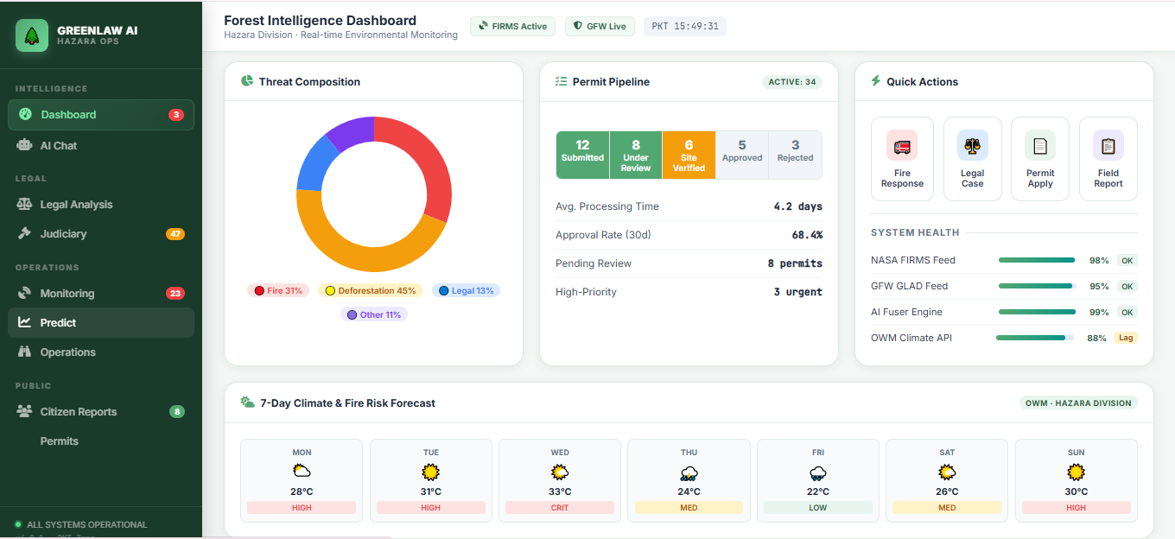Figure 1.1: GreenLawAI Intelligence Dashboard Overview
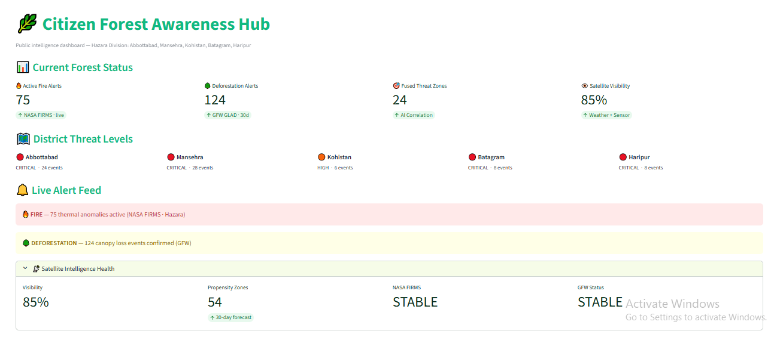
The GreenLawAI Intelligence Dashboard solves the problem of high-level situational blindness. It serves as a unified landing page for environmental regulators, department coordinators, and operations staff, giving them a real-time visual assessment of forest health, active threats (such as active fires and deforestation alerts), and enforcement metrics.
Figure 1.2: Citizen Forest Awareness Hub
The Citizen Forest Awareness Hub serves as a public interface. It allows citizens to view safe, aggregated forest health metrics, check general district threat levels, and securely report local forest issues (e.g., fires, logging) to the forest department while maintaining operational security
Existing legal information is neither easily searchable nor presented in accessible, plain language.

1.2 Problem Statement
Legal frameworks are often complex, dispersed across multiple documents, and written in technical language that makes them difficult for both the general public and even forestry officials to access and interpret effectively. In consultations with forestry departments and conservation organisations, it was identified that both citizens and officials frequently struggle to find clear, concise answers to practical questions such as: “What is the penalty for cutting a protected tree?” or “Do I need a permit to gather firewood?”
Incident reports documenting violations, wildfires, or conservation activities are often scattered and time-consuming to analyze. Similarly, public feedback on forestry initiatives, such as tree-planting campaigns, is rarely captured systematically, even though it reflects valuable community sentiment and engagement. Determining the legal status of specific tree species, assessing climate-related risks, and detecting trends in illegal activities, like increasing unauthorized logging in specific regions, currently demand considerable manual effort and expert knowledge. This fragmentation of data leads to high-level situational blindness for environmental regulators and department coordinators.
Furthermore, methods to automate driver classification for forest loss are currently limited. This task is challenging to automate due to the heterogeneity of drivers within images, the rapid evolution of landscapes over time, and the lack of expert-annotated data. Consequently, the lack of automated, spatially-broad, and temporally-dense driver attribution has significant negative implications for forest conservation policies. As a result, unintentional violations such as cutting protected trees, collecting firewood without permits, or engaging in unauthorized logging continue to threaten forest health, contribute to deforestation-driven carbon emissions, and undermine global climate resilience.

1.3 Research Objectives
To achieve the aim of simplifying forestry regulations and providing clear guidance, the project focuses on several key research objectives:

1.3.1 Development of a Structured Knowledge Base
The first objective is to develop a well-structured knowledge base by gathering and organizing official data from forestry laws, regulations, policies, incident records, and climate-related reports from diverse regions. This includes indexing federal forestry acts, provincial amendments, and judicial precedents, such as the Forest Act 1927, the KPK Forest Ordinance 2002, and the KPK Forest Amendment Act 2022. The project involves collecting forestry laws and incident reports from verified sources and then cleaning, preprocessing, and structuring this data into a searchable format. This data is stored within an intelligence layer utilizing FAISS vector storage for precedent cases and Neo4j knowledge graphs for statutes, entities, and code cross-references.

1.3.2 Design of a Conversational RAG Chatbot
The second objective is to design and build a conversational chatbot capable of addressing varied user questions about legal requirements, protected species, penalties, permits, and climate impacts. The system interacts with users in a conversational manner, allowing them to ask questions in natural language which the system interprets to provide accurate, context-aware responses. To ensure these answers are accurate and trustworthy, the project incorporates a Retrieval-Augmented Generation (RAG) approach, ensuring all responses are grounded in authentic legal and climate-related documents to avoid giving wrong or made-up answers. This pipeline utilizes a dual-chunking strategy and vector embeddings to match queries with the most relevant passages in the knowledge base.

1.3.3 Integration of Agentic AI Components
The third objective is to integrate Agentic AI components that enable the system to go beyond answering questions by proactively summarizing incident reports, detecting patterns of illegal activities, and suggesting climate-conscious recommendations to support conservation and resilience. Specialized agents are utilized to manage different tasks: a Law Agent for statutory grounding, a Climate Impact Agent for explaining forestry–climate connections, and a Monitoring Agent for detecting unusual patterns in reports, such as increased illegal logging. These agentic components enable proactive functions such as highlighting broader links between forestry practices and climate change impacts, such as deforestation-driven carbon emissions. The framework follows a plan-driven ReAct loop that separates planning from reasoning, allowing the system to execute complex multi-step tasks like investigating active incidents or predicting judicial outcomes.

1.4 Scope of Work
The scope of the GreenLawAI project covers the design, development, deployment, and evaluation of an intelligent chatbot enhanced with Agentic AI that delivers accurate, proactive, and context-aware information about forestry laws, policies, conservation efforts, and their links to climate change impacts. The project aims to create a system that serves both citizens and forestry officials. To achieve this, the project focuses on several key tasks: designing and implementing core chatbot functionality leveraging Python and modern development frameworks; building a comprehensive knowledge base by collecting and organizing forestry laws, policies, incident reports, and climate-related data; and developing and training Machine Learning and NLP models integrated with a Retrieval-Augmented Generation (RAG) framework to generate accurate and reliable responses.
Furthermore, the scope includes the integration of Agentic AI components to enable proactive summarization of incident reports, climate-aware recommendations, and the detection of unusual activity patterns. The implementation involves a web-based conversational interface for seamless interaction, as well as extensive testing, including unit, integration, and user-acceptance testing, to ensure the system’s accuracy, reliability, usability, and climate relevance. The backend system incorporates NLP models, RAG components, agentic reasoning, and machine learning algorithms grounded in a structured and verified forestry and climate knowledge base.
Figure 1.3: GreenLawAI Intelligence Dashboard Overview
The GreenLawAI Intelligence Dashboard solves the problem of high-level situational blindness by serving as a unified landing page for environmental regulators, department coordinators, and operations staff. It provides a real-time visual assessment of forest health, active threats, and enforcement metrics. As seen in the interface, the dashboard is the primary entry point for nine specialized intelligence modules, including the standard Chat, Legal Analysis, Environmental Monitoring, and Predictive Intelligence centers.
On load, the system calls get_monitoring_stats() to dynamically calculate telemetry data. The KPI row displays live counts of active fires (e.g., 75 Pakistan Range hits from NASA FIRMS), deforestation alerts (e.g., 124 GLAD alerts from GFW), and recent incidents registered in the incident agent. The dashboard also features a "Live Telemetry" indicator showing the exact timestamp of synchronization and a "7-Day Risk Forecast" that renders localized weather cards with temperature and warning alerts retrieved via the OpenWeatherMap API. Quick action buttons allow officials to force-navigate directly to legal queries or scan the tactical forest map.

Figure 1.4: Citizen Forest Awareness Hub
The Citizen Forest Awareness Hub serves as a public interface that allows citizens to view safe, aggregated forest health metrics and check general district threat levels. Upon loading, the system fetches live telemetry but strictly strips precise tracking data to maintain operational security (OpSec). As displayed in the hub, the interface provides a "Current Forest Status" summary showing fire alerts, canopy loss events, and fused threat zones correlated by AI.
The hub utilizes styled badges to classify "District Threat Levels" as Critical, High, or Stable for regions such as Abbottabad, Mansehra, Kohistan, Batagram, and Haripur. A "Live Alert Feed" provides simple informational banners about regional hazards. This module also includes a secure "Report a Forest Issue" form (not fully shown in this view) that allows citizens to submit descriptions of illegal logging or fires directly to the Divisional Forest Officer (DFO) via email and Slack while protecting ranger safety by concealing exact coordinates from the public view.

1.5 Significance of the Study
The motivation behind this project comes from the growing difficulty people face in understanding forestry laws and environmental regulations. Understanding forestry laws and policies is often challenging due to their complexity, which can leave people uncertain and may even lead to unintentional violations, such as unauthorized logging or collecting firewood without permits. These legal frameworks are often dispersed across multiple documents and written in technical language that makes them difficult for both the general public and even forestry officials to access and interpret effectively. As a result, these violations continue to threaten forest health, contribute to deforestation-driven carbon emissions, and undermine global climate resilience. By creating GreenLawAI, the aim is to make legal and environmental knowledge simple, reliable, and accessible for everyone.
The technical significance of the study is realized through a 5-Layer Reactive Decoupled Architecture built to fuse real-time satellite telemetry with autonomous agentic intelligence, legal RAG grounding, and multi-channel enforcement relays. This platform separates data ingestion from high-latency LLM agent pipelines, enabling real-time geospatial rendering alongside robust statutory reasoning. The Dashboard module specifically solves the problem of high-level situational blindness by serving as a unified landing page for environmental regulators, department coordinators, and operations staff. It gives them a real-time visual assessment of forest health, active threats, and enforcement metrics, providing a high-integrity framework for environmental enforcement through the integration of tactical GIS rendering and forensic reporting.
Furthermore, the study is significant for its ability to ground legal enforcement with spatial surveillance by integrating thirteen external systems, including NASA FIRMS for thermal anomalies and Global Forest Watch for canopy loss. An Intelligence Fusion Engine coordinates raw data parsing and spatial-temporal clustering to identify synergistic threats, such as thermal surges overlapping with canopy loss. The system delivers accurate and climate-aware responses using the IRAC (Issue, Rule, Application, and Conclusion) format, which is the gold standard for legal reasoning. This format disentangles complex hierarchies between federal acts and provincial ordinances, providing a traceable logic trail that human attorneys can verify.
Operationally, the study provides significance by digitizing the permitting workflow for timber, grazing, and transit, replacing manual paper-based processes with a streamlined digital submission flow and remote review protocol for Divisional Forest Officers. To ensure legal validity, the platform includes a forensic packaging workflow that translates satellite detections and operator decisions into court-admissible exhibits protected by SHA-256 cryptographic hashes. By uniting these capabilities, GreenLawAI increases legal awareness, fosters compliance, and strengthens both conservation and climate adaptation efforts. Ultimately, this contributes to improved forest management, environmental sustainability, and resilience to climate change on a broader scale within the Hazara Division and potentially globally.

1.6 Organization of the Project
Chapter 1: Introduction GreenLawAI is introduced as a smart chatbot with Agentic AI capabilities designed to simplify forestry regulations and provide clear, reliable guidance. The project addresses the problem of situational blindness by bridging the gap between complex policies and real-world understanding.
Chapter 2: Existing Systems and Literature Review This chapter reviews existing specialized assistants, identifying a gap in jurisdiction-specific legal systems. It further benchmarks research such as ForestNet and Tree-GPT to establish a foundation for automated driver classification and remote sensing expert systems.
Chapter 3: Methodology and System Architecture The 5-Layer Reactive Decoupled Architecture is detailed, which separates data ingestion from high-latency agent pipelines to enable real-time geospatial rendering alongside statutory reasoning. It elaborates on hybrid retrieval using FAISS and Neo4j, supported by mathematical models like the Haversine formula and carbon sequestration calculations.
Chapter 4: Implementation and Technical Deep Dive This chapter breaks down the implementation of the unified command portal and the technical roles of fifteen specialized agents. It focuses on the plan-driven ReAct loop for reasoning and the ForestWatchdog service for continuous background surveillance.
Chapter 5: Evaluation and Experimental Results Evaluation results are presented using the OutcomeAnalyzer for execution success and the Confidence Engine for legal grounding. The system's resiliency is validated through a failure grid for API outages alongside feature walkthroughs of the Legal Analysis Center and Permit Intelligence modules.
Chapter 6: Conclusion and Future Directions The report concludes by summarizing contributions toward grounding legal enforcement with spatial surveillance. It addresses limitations such as the reliance on single-satellite imagery and proposes future trajectories like global mapping and blockchain-secured registries.

CHAPTER 2:
EXISTING SYSTEMS AND LITERATURE REVIEW

2.1 Evaluation of Existing Systems
This section reviews current AI tools applied to forestry, contrasting general-purpose models with domain-specific solutions to identify their respective capabilities and limitations.

2.1.1 General vs. Specialized AI Systems in Forestry
Artificial intelligence is increasingly used in forestry and environmental management to understand laws, monitor compliance, and support communities. However, general AI tools like ChatGPT or Gemini can give incorrect or outdated answers because they aren’t trained on official legal data. This makes specialized AI systems, built on verified and accurate sources, essential for reliable guidance in forestry laws and policies. Currently, LLMs are unable to extract or comprehend information from images and may generate inaccurate text due to a lack of domain knowledge, limiting their use in forestry data analysis.

2.1.2 General LLM Limitations and Hallucination Challenges
LMMs like GPT series have left a profound impression due to their powerful intelligence, but the limited ability of LLMs to comprehend images and generate accurate domain-specific knowledge hinders their application in forest remote sensing data analysis. Most language models struggle to comprehend visual information, limiting their applicability. Furthermore, most language models exhibit limited performance when generating text in specific professional domains due to a lack of fine-tuning for those domains. A phenomenon known as “hallucination” is also commonly observed in language models, where they generate information that does not exist in reality, such as providing incorrect interpretations of natural laws. Consequently, the lack of remote sensing image understanding ability and accurate professional knowledge are significant issues that restrict the application of general language models in specialized domains.

2.1.3 Finn by SilviaTerra
Alongside general systems, a few specialized forestry assistants have been introduced. Finn by SilviaTerra is embedded within a forestry management platform and helps landowners and professionals generate management plans, analyze forest data, and answer technical questions. It allows researchers to employ LLMs to generate data analysis code in a matter of minutes, a task that previously required several tens of minutes to complete. However, while its strength lies in forestry operations, particularly in the North American context, it does not provide guidance on legal frameworks.

2.1.4 Advisor (YesChat)
Forestry Advisor (YesChat), a GPT-based agent, assists learners and practitioners by identifying tree species and offering advice on sustainable practices, pest management, and reforestation. This system helps users understand specific concepts in images and provides answers regarding the presence of specific concepts in the imagery. While useful for education and awareness, it is not designed to interpret or explain jurisdiction-specific laws. Because local models cannot always reliably generate syntactically correct tool calls, these GPT-based agents often rely on general reasoning rather than strict statutory grounding.

2.1.5 ForestChat (TimberNex)
Similarly, ForestChat (TimberNex) integrates into a forestry management suite to support GPS-based inventory, work orders, and team coordination, including offline functionality. These existing methods for individual tree crown (ITC) segmentation and operational tracking often utilize traditional morphological image segmentation or unsupervised clustering techniques. Yet, its focus remains operational rather than legal, leaving policy interpretation unaddressed.

2.1.6 Identified Gap: The Need for Legal and Statutory Reasoning
These examples demonstrate progress in AI-assisted forestry but also reveal a clear gap: the absence of systems that make forestry laws understandable, reliable, and jurisdiction-specific. Understanding forestry laws and policies is often challenging due to their complexity, which can leave people uncertain and may even lead to unintentional violations. Existing legal information is neither easily searchable nor presented in accessible, plain language. To address this, GreenLawAI is a specialized chatbot built with Retrieval-Augmented Generation (RAG) to provide answers based on real forestry laws and reports. It explains complex rules in simple words, summarizes reports, and identifies tree species and their legal status, making forestry laws easier to understand and apply.

2.2 Background and Motivation
Forests are indispensable for sustaining ecosystems, protecting biodiversity, regulating the climate, and supporting human communities. The preservation of forests is crucial for preventing loss of biodiversity, managing air and water quality, and mitigating climate change. Specifically, forest loss in the tropics contributes to around 10% of annual global greenhouse gas emissions and must be reduced to decrease the potential for climate tipping points. To safeguard these resources, governments have established forestry laws, policies, and regulations that define legal rights, protected areas, penalties, and operational procedures; however, understanding these frameworks is often challenging due to their complexity, which can leave people uncertain and may lead to unintentional violations, such as unauthorized logging.
Legal frameworks are often complex, dispersed across multiple documents, and written in technical language that makes them difficult for both the general public and even forestry officials to access and interpret effectively. In consultations with forestry departments and conservation organizations, several pressing challenges were identified: citizens and officials frequently struggle to find clear, concise answers to practical questions such as “What is the penalty for cutting a protected tree?” or “Do I need a permit to gather firewood?”. Existing legal information is neither easily searchable nor presented in accessible, plain language. Furthermore, incident reports documenting violations, wildfires, or conservation activities are often scattered and time-consuming to analyze. Determining the legal status of specific tree species, assessing climate-related risks, and detecting trends in illegal activities, like increasing unauthorized logging in specific regions, currently demand considerable manual effort and expert knowledge.
The motivation behind this project comes from the growing difficulty people face in understanding these forestry laws and environmental regulations. Many citizens and officials struggle to find clear guidance, which often leads to unintentional violations, such as cutting protected trees, collecting firewood without permits, or engaging in unauthorized logging, that threaten forest health and undermine global climate resilience. By creating GreenLawAI, the aim is to make legal and environmental knowledge simple, reliable, and accessible for everyone. GreenLawAI is built to fuse real-time satellite telemetry with autonomous agentic intelligence, legal RAG grounding, and multi-channel enforcement relays to bridge the gap between complex forestry policies and real-world understanding.
The system provides accurate and reliable responses to questions about regulations, fines, permits, and rights by drawing directly from official forestry documents, including federal acts, provincial amendments, and judicial precedents such as the Forest Act 1927, the KPK Forest Ordinance 2002, and KPK Forest Amendment Act 2022. By uniting these in a single platform, the project aims to increase legal awareness, foster compliance, and strengthen both conservation and climate adaptation efforts.

Table 2.1: Summary of Forest Ecosystem Services and Strategic Threats(Extended)
Feature | Service or Strategic Constraint | Operational Impact and Consequences
Ecosystem Role | Sustains biodiversity, regulates climate, and supports communities. | Indispensable for global ecological health and human support.
Feature | Service or Strategic Constraint | Operational Impact and Consequences
Data Accessibility | Existing legal data is dispersed and not easily searchable. | Citizens/officials struggle to find clear answers on penalties or permits.
Information Gap | Incident reports and conservation records are scattered. | Analysis is time-consuming and manual trend detection is slow.
Conservation Risk | Unintentional logging and permit violations. | Threatens forest health and undermines global climate resilience.

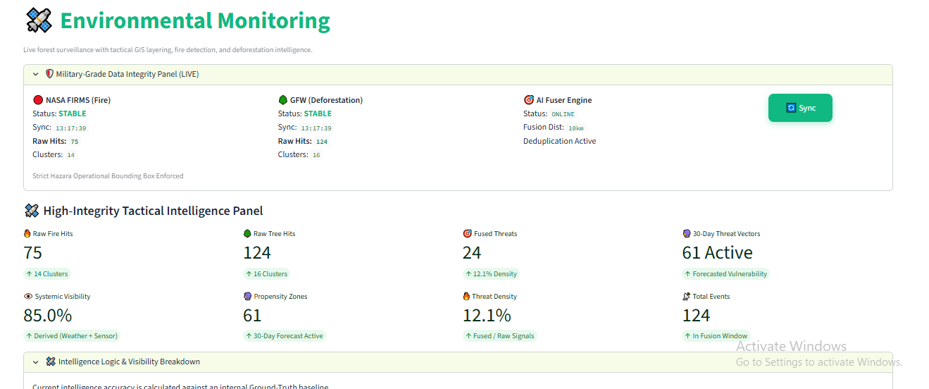Figure 2.1: Environmental Monitoring and Tactical Intelligence Dashboard
The Environmental Monitoring module provides tactical GIS situational awareness and is used by operators and command staff to scan the forest canopy, identify sensor anomalies, correlate raw feeds into high-confidence hazard points, and coordinate rapid response operations. The interface features a Military-Grade Data Integrity Panel that tracks the synchronization status for NASA FIRMS (Fire) and GFW (Deforestation) data streams, ensuring the AI Fuser Engine is online and deduplicating threats within a 10km spatial radius. As displayed in the High-Integrity Tactical Intelligence Panel, the dashboard calculates critical real-time KPIs, including raw fire and tree hits, fused threats, and 30-day threat vectors, to solve the problem of high-level situational blindness for environmental regulators and department coordinators.
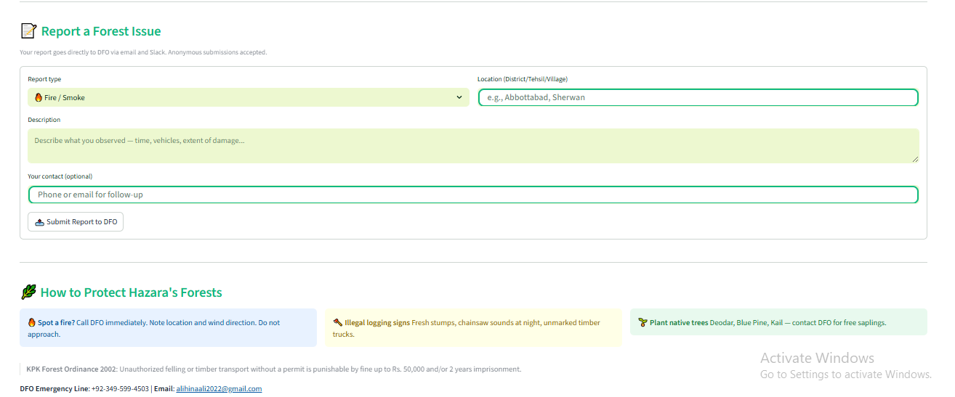
Figure 2.1: Citizen Forest Interaction and Reporting Interface
The Citizen Forest Awareness Hub serves as a public interface that allows citizens to view safe, aggregated forest health metrics and securely report local forest issues, such as fires, smoke, or illegal logging, to the forest department. The interface features a secure reporting module where submissions are dispatched directly to the Divisional Forest Officer (DFO) via email and Slack alerts; this form captures essential observation details, including the time, any vehicles involved, and the extent of damage while accepting anonymous submissions to encourage community participation. Furthermore, the hub fosters public engagement through educational guidance on native species for planting, such as Deodar, Blue Pine, and Kail, and provides clear legal notices regarding penalties for unauthorized felling under the KPK Forest Ordinance 2002.

2.3 Modular LLM Expert Systems: Analysis of Tree-GPT
This section examines Tree-GPT, a modular framework that integrates image understanding, domain knowledge, and code execution to enhance LLM capabilities for forestry remote sensing data analysis.

2.3.1 Framework Overview and Motivation
Analysis of forest remote sensing data is essential for various applications in forestry and environmental sciences. Currently, Large Language Models (LLMs) are unable to extract or comprehend information from images and may generate inaccurate text due to a lack of domain knowledge, limiting their use in forestry data analysis. To address this issue, a novel framework called Tree-GPT is proposed, which incorporates LLMs into the forestry remote sensing data workflow, thereby enhancing the efficiency of data analysis. Tree-GPT is a modular LLM expert system that integrates image understanding modules, domain knowledge bases, and toolchains. This empowers LLMs with the ability to comprehend images, acquire accurate knowledge, generate code, and perform data analysis in a local environment.

2.3.2 Core Architectural Components
The core of this system consists of an LLM as the reasoning engine, an image understanding module to convert image information into text, a Domain Knowledge Base to store professional knowledge for LLM retrieval, and an LLM execution agent for code execution. Specifically:
- LLM Reasoning Engine: The system utilizes models like GPT-4 to comprehend human natural language instructions and generate coherent text.
- Image Understanding Module: This module extracts structured information from forest remote sensing images, focusing on individual tree crown (ITC) segmentation and calculation of tree structural parameters.
- Domain Knowledge Base: A vector database that stores forest ecology domain-specific knowledge in embedded text form to tackle the issue of hallucination.
- LLM Execution Agent: A backend framework that connects the LLM’s code outputs with the local runtime environment to execute generated code, perform data manipulation, and generate visualizations.

2.3.3 Tree-GPT Modular Framework
The framework of Tree-GPT is designed to bridge the gap between visual remote sensing data and natural language reasoning. It consists of four primary interconnected blocks that facilitate a seamless data-to-insight workflow.
- Prompt Generation: This initial phase involves taking a forest image and passing it through either the DeepForest detection model or human Interaction to generate a "Bbox Prompt" (bounding box).
- Image Understanding Module: The Bbox Prompt guides the Segment Anything Model (SAM) with a Vit-H backbone to generate redundant Masks. These masks undergo a mathematical Matching process to produce refined 2D and 3D Masks. These results are then used for Structure Factors Estimation (Height, Area, Location, Crown width), which are stored in the Tree Factor Database.
- Domain Knowledge Base: Forestry knowledge is processed through OpenAI Embedding & Splitting and stored in a Chroma Vector Database. This allows for Similarity Search when a user query is received.
- LLM & Execution Agent: The user interacts via a WebUI. The LLM (ChatGPT or GPT-4) receives text embeddings and context, generating code. The Agent executes this code in a Develop Environment, outputting Visualization Results (e.g., scatter plots, 3D point cloud segmentations) back to the WebUI.

2.3.4 Individual Tree Crown (ITC) Segmentation
ITC segmentation remains a challenging problem, as accurately describing tree boundaries is difficult due to the lack of texture information in point clouds. To reduce the cost of deep learning approaches that require a large number of high-precision training samples, Tree-GPT considers unsupervised or interactive methods for ITC segmentation. The study employs the Segment Anything Model (SAM) as the core, which can perform zero-shot image segmentation guided by prompts. To control the segmentation granularity, Tree-GPT uses points and target frames as SAM’s prompts simultaneously to guide the generation of tree masks.

2.3.5 Bipartite Graph Matching for Optimal Mask Selection
Since SAM’s segmentation results do not contain semantic information, Tree-GPT must select the optimal results that correspond one-to-one with the real trees. This matching problem is modeled as a bipartite graph matching problem in mathematics. The system aims to maximize the overlap between the segmentation result and the detected target frame using the Generalized Intersection over Union (GIoU) metric. After obtaining a cost matrix, the classic Hungarian algorithm is used to solve the bipartite matching and obtain the optimal segmentation result with the highest overlap with the tree position.

2.3.6 Domain Knowledge Retrieval and Task Planning
The Domain Knowledge Base uses the FAISS (Facebook AI Similarity Search) algorithm to retrieve relevant information from the Chroma database. When the LLM execution agent receives a task, it decomposes natural language instructions into subtasks using prompt templates. This "Task Planning" ensures that the LLM generates accurate code for simpler, broken-down tasks. The agent then executes the code in a local runtime environment, calling upon the tree databases and remote sensing images to generate visualizations or statistical learning-based analyses.

2.4 ForestNet Primary Forest Loss Driver Classification
The ForestNet pipeline demonstrates how deep learning can be applied to classify the direct drivers of deforestation using satellite imagery. This automation enables spatially-broad and temporally-dense driver attribution for forest conservation policies.
- Input Selection: The process begins with identifying a Forest Loss Region from Global Forest Change maps. A Landsat 8 Satellite Image is centered around this region.
- Model Architecture: The image is fed into the ForestNet model (a CNN utilizing a Feature Pyramid Network architecture). The model performs Per-pixel Classification to identify various land uses within the region.
- Multi-Modal Fusion: To enhance accuracy, the system incorporates auxiliary predictors such as Elevation and Proximity to roads or cities. These variables are concatenated to the segmentation logits.
- Classification Output: The final output is a Primary Forest Loss Driver Classification, categorizing the loss event into groups such as Plantation, Smallholder Agriculture, Grassland/shrubland, or Other.

Conclusion:
The literature review demonstrates that while artificial intelligence is increasingly used in forestry and environmental management, general AI tools like ChatGPT or Gemini often generate inaccurate text due to a lack of domain knowledge and a phenomenon known as “hallucination”. Specialized systems such as Finn by SilviaTerra and Forestry Advisor (YesChat) have made progress in assisting with management plans and tree species identification, yet they are not designed to interpret or explain jurisdiction-specific laws. This reveals a clear gap: the absence of systems that make forestry laws understandable, reliable, and jurisdiction-specific. GreenLawAI is designed to address this deficiency by utilizing a Retrieval-Augmented Generation (RAG) approach to provide answers based on real forestry laws and reports, making regulations easier to understand and apply.
Technical advancements in deep learning and modular expert systems provide a robust foundation for this work. The ForestNet model illustrates that deep learning can successfully classify direct drivers of primary forest loss, such as plantations and smallholder agriculture, substantially outperforming standard approaches. Furthermore, the Tree-GPT framework proves that a modular LLM expert system integrating image understanding modules and domain knowledge bases can empower LLMs to comprehend images and perform complex data analysis in a local environment. By automating driver classification and image-based analysis, these methods enable more spatially-broad and temporally-dense insights with significant implications for forest conservation policies.
In conclusion, the integration of these methodologies allows GreenLawAI to go beyond simple question-answering. By uniting the high-resolution driver classification capabilities seen in ForestNet and the modular reasoning approach of Tree-GPT, the project aims to bridge the gap between complex forestry policies and real-world understanding. The system will simplify access to complex forestry laws and policies by delivering accurate, timely, and climate-aware responses while proactively detecting patterns of illegal activities to support global climate resilience. This research establishes a forward-looking tool for anyone who needs information on forestry regulations, conservation work, and their critical connection to climate change.

CHAPTER 3:

SYSTEM METHODOLOGY AND DESIGN

GreenLawAI utilizes a 5-Layer Reactive Decoupled Architecture. It separates data ingestion from high-latency LLM agent pipelines, enabling real-time geospatial rendering alongside robust statutory reasoning. The platform is built to fuse real-time satellite telemetry with autonomous agentic intelligence, legal RAG grounding, and multi-channel enforcement relays. This chapter details the core data algorithms, mathematical formulations, and spatial logic implemented to coordinate raw data parsing, spatial-temporal clustering, weather-vector propagation, and reverse-geocoding resolution. Furthermore, it provides a detailed explanation and visualization of the Retrieval-Augmented Generation (RAG) pipeline and legal knowledge system, including the configuration of Agentic AI components to manage multi-step reasoning and task orchestration. The system follows a plan-driven ReAct loop that separates planning from reasoning to ensure reliability and grounding in authentic legal and climate-related documents.

3.1 GreenLawAI 5-Layer Reactive Decoupled Architecture
GreenLawAI utilizes a 5-Layer Reactive Decoupled Architecture. It separates data ingestion from high-latency LLM agent pipelines, enabling real-time geospatial rendering alongside robust statutory reasoning. This platform is built to fuse real-time satellite telemetry with autonomous agentic intelligence, legal RAG grounding, and multi-channel enforcement relays.

Layer 1: Data Ingestion Layer
The Data Ingestion Layer handles raw, IO-bound REST API operations from multiple external environmental data providers. This layer utilizes the NASA FIRMS API to fetch active thermal anomalies in Pakistan via the FIRMSFireMonitor . It simultaneously queries Global Forest Watch (GFW) via the GFWDeforestationMonitor to fetch GLAD canopy loss alerts. Additionally, the OpenWeatherMap API is instantiated via the WeatherMonitor to retrieve localized forecast JSON files for Abbottabad. To prevent API rate limit exhaustion and ensure seamless fallback logic, the system implements a 60-second st.cache_data Time-To-Live (TTL) for raw telemetry.

Layer 2: Processing & Fusion Layer
The Processing & Fusion Layer isolates computationally expensive CPU-bound deduplication, spatial clustering, and bounding box checks. The Intelligence Fusion Engine coordinates raw data parsing, spatial-temporal clustering, weather-vector propagation, and reverse-geocoding resolution. This layer merges GFW deforestation pixels and NASA thermal pixels, deduplicating events within a 10km spatial radius using a DBSCAN-Lite spatial clustering. Decoupling this from the ingestion layer ensures that if one feed experiences a network timeout, the system can instantly apply zero-latency fallback logic while continuing to deduplicate threats smoothly in the. It also features a 30-Day Predictor to model vulnerability vectors and wind risks.

Layer 3: Intelligence & Grounding Layer
The Intelligence Layer acts as the reasoning core, featuring an Agentic Coordinator that manages specialized AI agents. These agents, including the Law Agent, Climate Agent, and Monitoring Agent, interact with FAISS Vector Storage for precedent cases and a Neo4j Knowledge Graph for statutes and entities. The system utilizes a Pydantic-based CanonicalAgentResponse schema to enforce mandatory grounding; agents must accompany statements with structured citations matching source vectors, or the schema throws a validation error. A "Hallucination Guard" and "Confidence Engine" further verify text alignments and award graph bonuses for valid Neo4j path traversals.

Layer 4: Presentation Layer
The Presentation Layer is implemented as a unified 9-page Command & Control Streamlit Portal located at portal.py. Keeping the 9 intelligence modules in a single orchestrating entrypoint guarantees seamless variable references and prevents the loss of session state, such as chat histories or operator decisions. This layer provides a real-time visual assessment of forest health, active threats, and enforcement metrics through nine specialized modules, including the Dashboard, Legal Analysis Center, and Environmental Monitoring. Operators use this layer to scan the forest canopy, identify sensor anomalies, and coordinate rapid response operations via dynamic Folium map rendering.

Layer 5: Communication & Enforcement Layer
The Communication & Enforcement Layer manages tactical alert distribution and official reporting. It features a Slack Gateway for real-time alarm dispatch, an official Email Relay for DFO case outreach, and a WhatsApp messenger via CallMeBot. To support legal actions, a PDF Evidence Engine generates SHA-256 digitally signed exhibits, ensuring chain-of-custody for court-admissible reports. This layer also includes an autonomous dispatch loop that enforces a 1-hour cooldown window per incident cluster to protect local authorities from alert fatigue. A Blockchain Ledger is integrated for maintaining tamper-proof case registries.
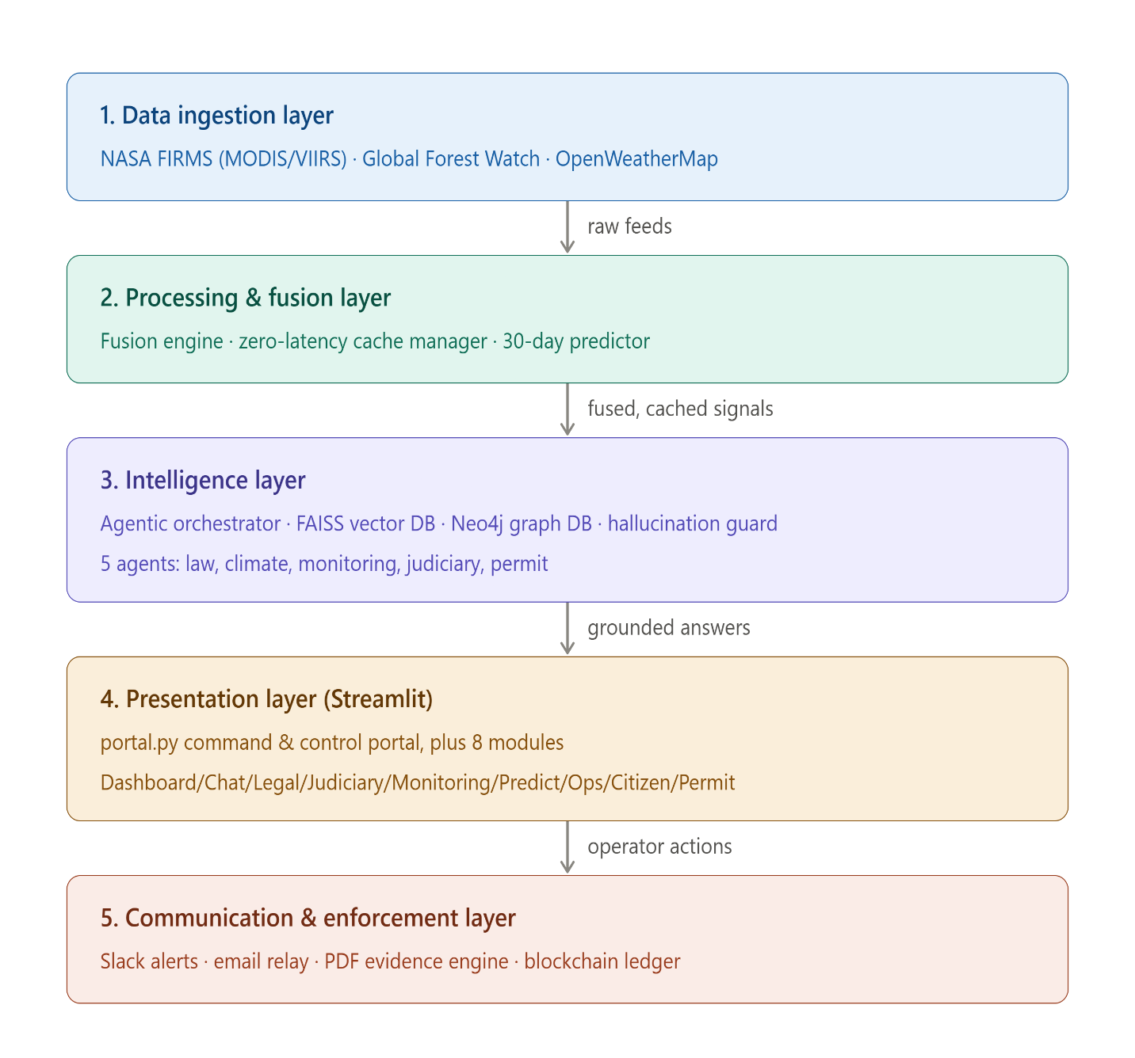Figure 3.1: Top-Level System Architecture Flowchart
The above diagram illustrates the decoupled layers of the GreenLawAI system, from data ingestion to enforcement communication.
The following table provides a complete architectural analysis of external integration points and their respective roles.

Table 3.1: Master Integration Map (External Endpoints)
# | System | Protocol | Endpoint | Role
1 | NASA FIRMS | HTTPS | firms.modaps.eosdis.nasa.gov/api/area | Real-time fire detections.
2 | GFW | HTTPS | data-api.globalforestwatch.org/dataset/... | GLAD canopy loss alerts.
3 | OpenWeather | HTTPS | api.openweathermap.org/data/2.5/weather | Microclimate for fire risk.
4 | GDACS | HTTPS | gdacs.org/xml/rss.xml | Natural disaster monitoring.
5 | Slack | HTTPS | slack.com/api/* | Tactical team alarms.
6 | Email Relay | HTTPS | {EMAIL_RELAY_URL} (Apps Script) | Official DFO outreach.
7 | CallMeBot | HTTPS | api.callmebot.com/whatsapp.php | Urgent pocket alerts.
8 | Nominatim | HTTPS | nominatim.openstreetmap.org/reverse | Reverse geocoding .
9 | Neo4j | Bolt TCP | bolt://localhost:7687 | Knowledge Graph traversal.
10 | FAISS | Local File | e:\GL_AI\data_processed\faiss_index_unified | Statutory semantic search.

3.2 Mathematical Formulations and Spatial Logic
The GreenLawAI platform implements a series of rigorous mathematical formulations to ground its spatial intelligence and predictive assessments. These formulas enable the system to translate raw sensor telemetry into actionable risk metrics, ensuring that legal enforcement and conservation efforts are guided by verifiable data.

3.2.1 Haversine Spatial Clustering and Great-Circle Distances
GreenLawAI utilizes the Haversine formula to coordinate raw data parsing and spatial-temporal clustering. Euclidean calculations are standard for flat Cartesian grids, but they assume a flat surface and therefore introduce significant distortion at higher latitudes where longitude lines converge toward the poles. In the Hazara Region, specifically around latitude 34∘N, a degree of longitude is shorter than a degree of latitude, measuring approximately 92 km versus 111 km respectively. Utilizing a standard Euclidean formula in this context would skew spatial buffers into ellipses, whereas the Haversine formula accounts for the Earth's curvature to maintain spherical accuracy.
The Haversine formula calculates the great-circle distance (d) between two coordinate points on a sphere of radius R, which is standardized at approximately 6371 km for Earth. The calculation requires converting latitude (ϕ) and longitude (λ) into radians to determine the central angle between the points. The resulting distance provides a high-fidelity spatial metric that allows the system to accurately determine if a satellite hit falls within a specific forest beat or jurisdiction.
The system implements a 10km fusion radius as a spatial filter to manage incoming telemetry. 10km represents the typical operational command radius for localized forest management beats in the Hazara Division. By using a DBSCAN-Lite spatial clustering implementation, the engine groups related telemetry feeds, such as a wildfire spreading across a ridgeline, into a single, actionable "correlated_threat" event. This process prevents operator alert fatigue by collapsing redundant signals, such as transforming a dense set of 919 raw alerts into approximately 80 manageable clusters.
This clustering process involves high computational complexity, estimated at O(N2) because the implementation must compare every event against every other event in a nested loop. For a dataset of 795 points, this necessitates over 315,000 Haversine operations. To prevent this from degrading UI responsiveness on every Streamlit page rerun, the system utilizes the st.cache_data wrapper to store results for 120 seconds, ensuring that intensive spatial-temporal deduplication only occurs when new telemetry is ingested.
Furthermore, fused threats receive a confidence boost based on sensor diversity. If the distance between the centroid of a fire cluster from NASA and a deforestation cluster from GFW is less than 10km, the system upgrades the event to a "CRITICAL" severity. The confidence score is mathematically adjusted using a sensor diversity multiplier: Confidence=min(0.98,Max Raw Confidence+(Sensor Count×0.12)+Jitter). This ensures that overlapping evidence from independent satellite arrays results in a higher priority for ranger dispatch.
3.2.2 Carbon Risk Sequestration Model
The carbon risk sequestration model estimates the total metric tonnes of carbon dioxide (MTCO₂) at risk within a specific threat cluster. This calculation is essential for providing climate‑aware legal briefings, allowing the system to articulate the environmental cost of a violation. The model combines two distinct factors: the immediate biomass carbon release, which is a one‑time release from potential felling, and the lost sequestration capacity, which is modeled over a 1‑year horizon.
The total risk is defined by the formula:
R_total = C_biomass + S_lost
The first component, C_biomass, calculates the carbon currently stored in the standing trees by assuming dry tree biomass is approximately 50% carbon. The system then applies the molecular weight conversion ratio of Carbon to CO₂, which is:
44 / 12 ≈ 3.67
The affected area is estimated by multiplying the number of signals in a cluster by a standard 5.0‑hectare buffer per hit.
The second component, S_lost, accounts for the annual weight of CO₂ that would have been sequestered by the trees had they remained standing. This allows the system to project the long‑term climate impact of a single deforestation event. The calculation utilizes a standardized density for Hazara forests, set at 250 trees per hectare, to estimate the total tree count across the affected zone.
To ensure accuracy across different forest types, biomass factors are loaded from a specific fao_reference.json file. These factors vary by species; for instance, a mature Deodar Cedar is assigned a biomass factor of 450 kg/tree and an annual sequestration rate of 150 kg CO₂/tree. In contrast, dry scrub has significantly lower factors, with 120 kg/tree for biomass and 45 kg CO₂/tree for sequestration. This species‑specific granularity allows the AI to provide detailed reports on the exact ecological value of the specific area under threat.
Table 3.2 – FAO Biomass Factors by Species (Hazara Standards)
Species | Key | Biomass Factor (kg/tree) | Annual Sequestration (kg CO2/tree)
Deodar Cedar | deodar | 450 | 150
Kail (Blue Pine) | blue_pine | 320 | 110
Chir Pine | chir_pine | 280 | 95
Dry Scrub | scrub | 120 | 45

3.2.3 Fire Risk Index and Threat Analysis
The weather pipeline ingests real‑time meteorological metrics to calculate fire susceptibility indexes, fire spread rates, and immediate threat arrival times (ETA) for nearby villages. The Fire Risk Index is a simple index (0–100) that weights temperature, humidity, and wind velocity. Specifically, the temperature score is capped at 45°C and multiplied by 1.5, while humidity is subtracted from 100 and multiplied by 0.8:
Temperature Score = min(T, 45) × 1.5
Humidity Score = (100 – H) × 0.8
(An additional wind‑speed score is added to complete the total index, ensuring that hot, dry, and windy conditions correctly trigger "HIGH" risk alerts on the dashboard.)
Beyond static risk, the system calculates linear fire front spread rates (km/h) using a simplified terrain and fuel model. This formulation considers a "Slope Factor" to account for the fact that fire spreads faster uphill:
Slope Factor = 1.0 + slope / 20.0
The "Base Spread Rate" is established using wind speed, and the final rate is modulated by fuel density. This allows the Monitoring Agent to predict how quickly an active thermal anomaly might reach a protected forest boundary.
The system also calculates a "Village Threat Score" to prioritize emergency response. This score modulates the base fire risk based on the proximity of active fire centroids to human settlements using an exponential decay model:
Proximity Boost = 1.0 + 1.0 / (1.0 + e^(0.1 × (distance_km – 10)))
If the wind vector is blowing directly towards the village with less than a 45° angle difference and the distance is under 40 km, the score is further multiplied by 1.5 to reflect the immediate danger to life and property.
Figure 3.2: High-Integrity Tactical Intelligence Panel
This interface displays the real-time application of the formulations above. The "Fused Threats" metric uses the Haversine clustering logic, while "Biomass @ Risk" and "Total MTCO2 Vulnerable" are generated by the Carbon Sequestration Model. The "Systemic Visibility" percentage reflects the atmospheric correction factor applied to the satellite recall rates.
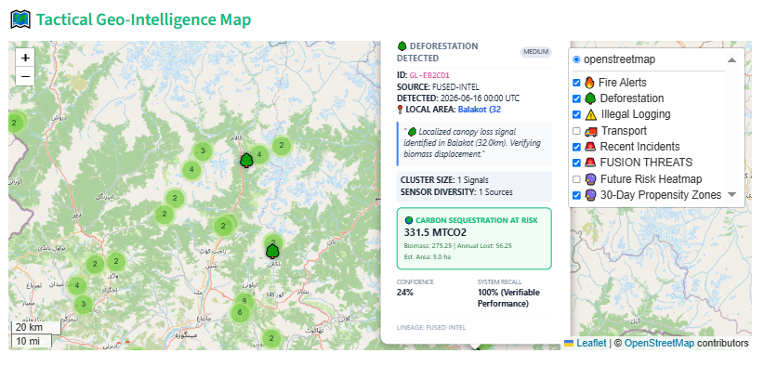
Figure 3.3: Tactical Geo-Intelligence Map with Carbon Detail
When an operator clicks a deforestation event on the tactical map, the detail panel renders the output of the CarbonCalculator.estimate_at_risk() method. As shown in the example, a cluster of 1 signal (5.0 hectares) of Deodar Cedar resulted in a calculated carbon sequestration risk of 331.5 MTCO2.

3.3 Knowledge Graph and RAG Strategy
GreenLawAI utilizes a sophisticated Retrieval-Augmented Generation (RAG) pipeline designed to index federal forestry acts, provincial amendments, and judicial precedents. The system ensures high-fidelity legal grounding by combining semantic vector search via FAISS with knowledge graph traversal via Neo4j. This hybrid approach allows the chatbot to provide accurate and reliable responses to complex questions about regulations, fines, and protected species while avoiding hallucinations.

3.3.1 Dual-Chunking Strategy: Semantic vs. Legal Chunking
The platform utilizes a dual-chunking strategy optimized for both vector indexing and graph mapping. This ensures that legal text is broken down into segments that preserve contextual meaning and statutory hierarchy. Respecting legal structures is critical to prevent breaking up cohesive provisions, such as separating an offence from its specific penalty.
3.3.1.1 Vector Indexing Chunking (SemanticChunker)
The SemanticChunker is designed for high-dimensional vector search. Chunks are limited to a maximum size of 512 tokens (approximately 2048 characters) and a minimum size of 120 tokens. The chunker scans for structural markers, including CHAPTER, Section, Clause, and SCHEDULE, to maintain boundary respect. To avoid losing context, a SmallChunkAggregator merges fragments smaller than the minimum size into neighboring chunks.
3.3.1.2 Graph Construction Chunking (LegalChunker) The LegalChunker focuses on character-based limits to match Neo4j entity mentions. It employs a maximum chunk size of 1000 characters with a 100-character overlap between adjacent segments. Similar to the semantic approach, it aggregates any chunk smaller than 150 characters with adjacent chunks. This strategy ensures clean, structured data that can be effectively mapped to nodes and relationships within the knowledge graph.

3.3.2 Neo4j Graph Schema and Entity Mapping
The Neo4j Knowledge Graph acts as the structural foundation of the intelligence layer, mapping the strict connections between laws, penalties, and species. This enables multi-hop queries that standard vector stores cannot execute, such as temporal walks to find the latest active penalties across multiple legislative amendments.
3.3.2.1 Node Labels (NodeLabel Enum)
The graph schema includes a comprehensive set of node labels to categorize legal and environmental entities. Primary labels include Law (parent statutes like the Forest Act 1927), Section (individual statutory sections), Penalty (fine values and prison terms), and Species (protected flora such as Deodar). Additional labels, such as Officer, Location, Amendment, and DocumentChunk, allow the system to map administrative authorities and geographic jurisdictions.
3.3.2.2 Relationship Types (RelationshipType Enum)
Relationships define the legal logic and hierarchy between nodes. Key relationship types include HAS_SECTION (connecting a Law to its Sections), IMPOSES (linking a Section to its specific Penalties), and PROTECTS_SPECIES (connecting a Law to regulated flora). Other critical links include APPLIES_TO for jurisdictional scoping, AMENDED_BY for legislative modifications, and MENTIONS to link document fragments to specific legal entities.
3.3.3 Hybrid Retrieval and Expert Knowledge Overlay (EKO)
To ensure the most accurate results, GreenLawAI merges chunks from both FAISS and Neo4j using a weighted scoring formula:
Final Score = 0.60 × V_score + 0.30 × G_score + 0.10 × Entity Overlap
The system also implements "Re-ranking Boosts," where chunks associated with a specifically requested section (e.g., "Section 26") have their scores elevated to a minimum of 0.85.The system further implements an Expert Knowledge Overlay (EKO). This is a registry of "golden rule-based facts" that are prepended at the very top of search results with a score of 1.0. For example, if a query mentions "Deodar" and "fine," the EKO surfaces the Schedule‑III penalty of Rs. 206,000 immediately. This ensures that the most critical legal knowledge is always surfaced to the user regardless of index quality.
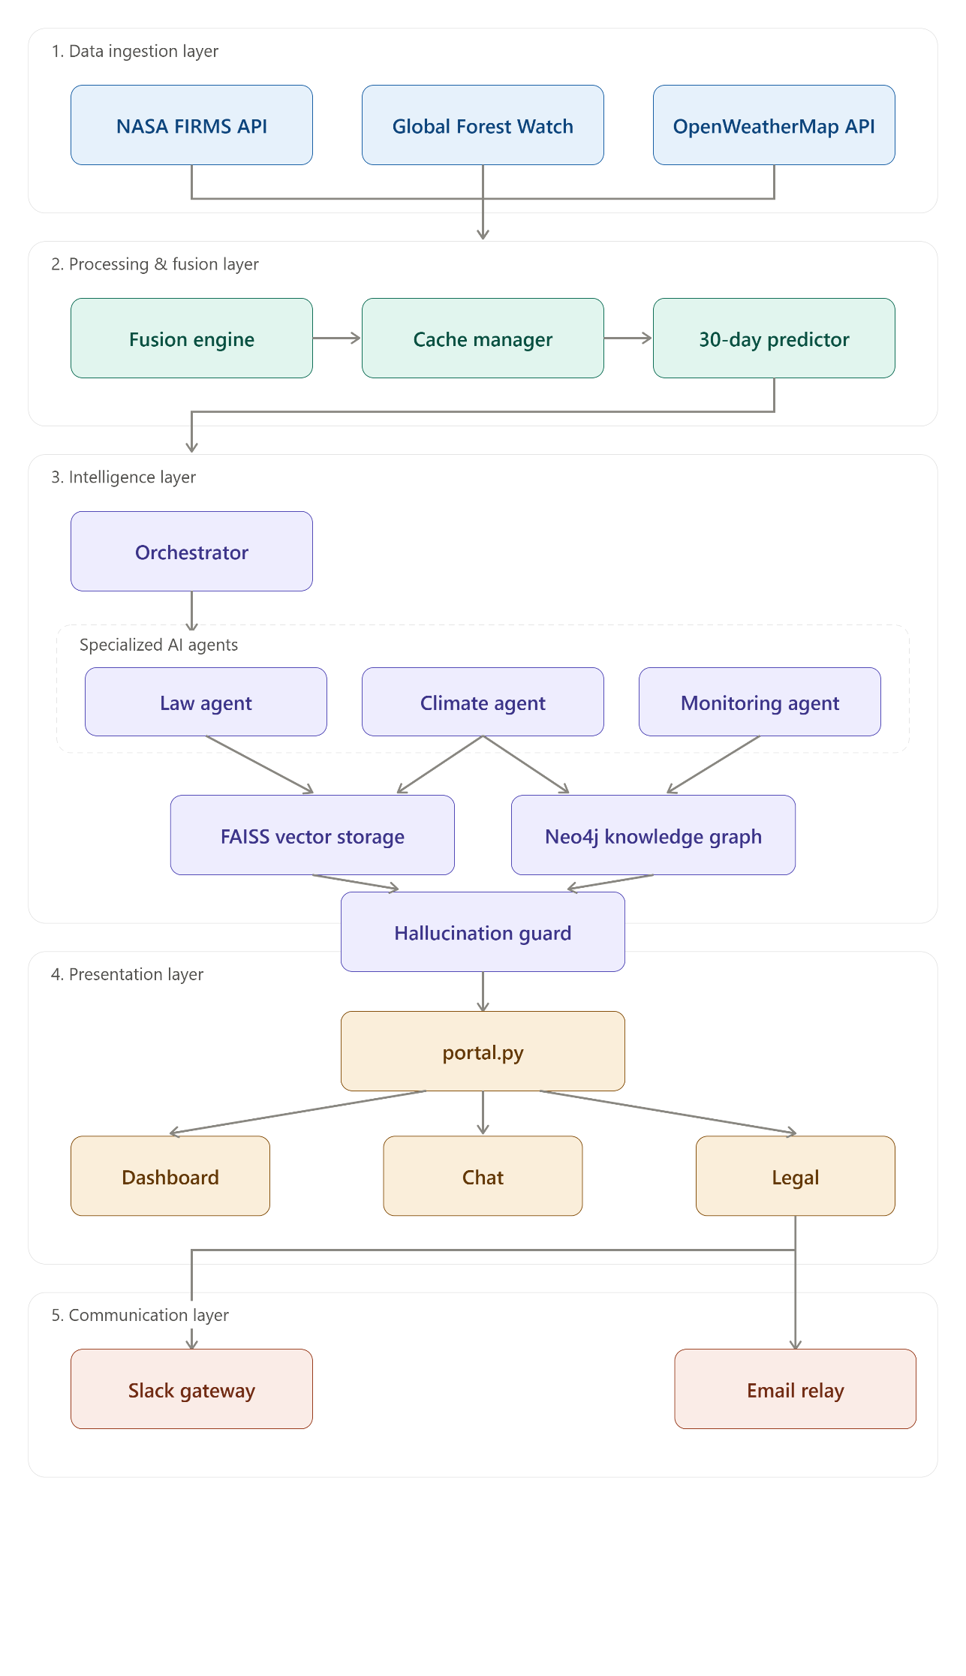
Figure 3.4: Top-Level System Architecture Flowchart
The following diagram illustrates the 5-layer decoupled architecture of the GreenLawAI system, showing how the Intelligence Layer (Layer 3) coordinates with the Vector and Graph databases.

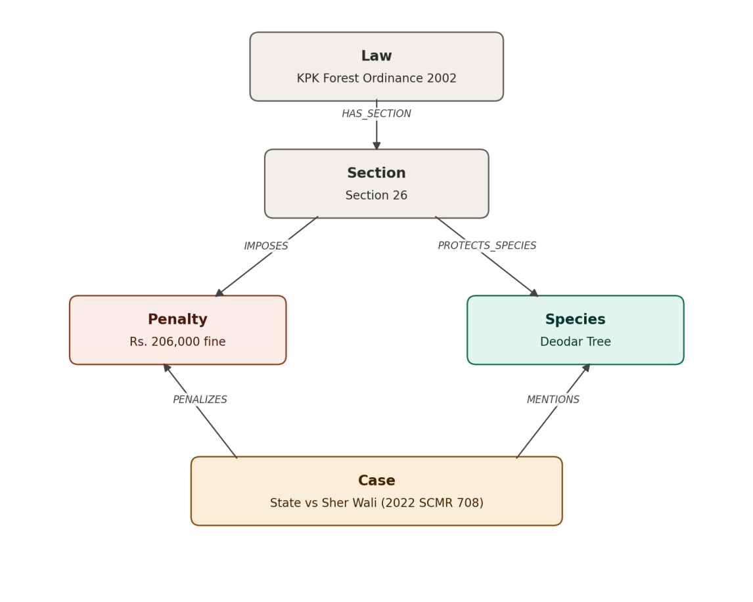
Figure 3.5: Neo4j Graph Schema Structure Diagram
This diagram visualizes the relationships between statutes, sections, penalties, and species as mapped in the knowledge graph.
The following table lists the ecological constants used by the CarbonCalculator to estimate environmental loss in reported incidents.
Table 3.2: FAO Biomass Factors by Species(2 only) (Hazara Standards)
Species | Key | Biomass Factor (kg/tree) | Annual Sequestration (kg CO2/tree)
Deodar Cedar | deodar | 450 | 150
Kail (Blue Pine) | blue_pine | 320 | 110

Conclusion:
The design and implementation of GreenLawAI’s 5-Layer Reactive Decoupled Architecture provide a robust technical foundation for modern forestry governance by effectively separating high-latency reasoning from real-time data ingestion. This structural decoupling ensures that tactical GIS situational awareness and environmental monitoring can occur concurrently with complex statutory reasoning provided by the Intelligence Layer. By utilizing a hybrid retrieval strategy that merges semantic vector search via FAISS with the relational structural walk of a Neo4j knowledge graph, the system achieves high-fidelity legal grounding while enforcing mandatory verification via the `CanonicalAgentResponse` schema.
The system’s methodology is further grounded in rigorous mathematical formulations, such as the Haversine formula for spherical spatial clustering and the Carbon Risk Sequestration model, which translates raw canopy loss into verifiable metric tonnes of carbon risk. The integration of a plan-driven ReAct loop allows the Agentic Coordinator to transcend passive information retrieval, enabling proactive tasks like autonomous wildfire dispatching and predictive propensity forecasting based on historical incident density and microclimate telemetry. These components are governed by a "Hallucination Guard" and "Confidence Engine" that verify text alignments and reward graph traversals, ensuring that every output delivered to citizens or officials is accurate, trustworthy, and climate-aware.
In conclusion, the design of GreenLawAI establishes a high-performance framework that bridges the gap between complex legal data and operational field needs. By maintaining strict operational security through public data filtering policies and ensuring accountability through a digitally signed PDF evidence engine and a persistent intelligence audit trail, the system provides a court-ready solution for environmental enforcement. This multi-layered approach ensures that the platform remains a scalable and reliable tool for fostering legal compliance, simplifying permits, and strengthening climate resilience within the Hazara Division.

CHAPTER 4:

IMPLEMENTATION AND TECHNICAL DEEP DIVE

The implementation of GreenLawAI is realized through a unified portal located at portal.py, which integrates nine specialized intelligence modules including the Dashboard, Intelligence Chat, and Legal Analysis Center. This platform is engineered to fuse real-time satellite telemetry with autonomous agentic intelligence, legal RAG grounding, and multi-channel enforcement relays. To achieve rapid visual rendering alongside high-integrity reasoning, the system is built with a highly curated, premium Python-centric stack that avoids generic defaults.
At its core, the system integrates with thirteen external systems across four primary categories: Environmental Data (NASA, GFW, OpenWeather, GDACS), Geocoding (Nominatim), Legal Retrieval (Neo4j, FAISS), and Communication (Slack, Email, WhatsApp, SMS, Teams, DFO). This production-level architecture details how raw satellite feeds and environmental data are ingested, processed, cached, fused, and translated into actionable intelligence on the GreenLaw AI dashboard. To ensure reliability, every data API is equipped with a fallback path, and every communication channel is designed to be independently failable.
The technical depth of the system is further defined by its multi-agent architecture, which covers base classes, individual agent roles, an orchestration graph, and forensic evidence packaging workflows. The system features a sophisticated Retrieval-Augmented Generation (RAG) pipeline and legal knowledge system that indexes federal forestry acts, provincial amendments, and judicial precedents. Coordination of these capabilities is managed by two orchestration systems: an AgentCoordinator that routes queries dynamically based on intent, and an AgenticCoordinator that executes autonomous sequential tool plans.

4.1 Multi-Agent System (MAS) Profiling
GreenLawAI utilizes a sophisticated multi-agent architecture engineered to provide high-integrity reasoning across legal, environmental, and operational domains. This system is comprised of 15 specialized agents that operate within a decoupled intelligence layer, ensuring that complex statutory reasoning remains distinct from real-time data ingestion. All agents in the system inherit from a BaseAgent class, which defines a standard interface and lifecycle for Retrieval-Augmented Generation (RAG) and tool execution.
4.1.1 The BaseAgent Contract and Lifecycle
The foundation of the multi-agent system is the BaseAgent abstract class, which enforces a strict producer interface. This class manages the agent’s lifecycle through load() and shutdown() methods and provides a single entry point for all operations via the run() method. It also includes a use_tool() asynchronous method that facilitates communication with the static ToolExecutor to interact with external systems like NASA FIRMS or Slack.

4.1.2 Mandatory Grounding: The CanonicalAgentResponse Schema
To prevent hallucinations, the system utilizes a Pydantic-based data contract known as the CanonicalAgentResponse. This schema enforces mandatory grounding by requiring that any non-abstaining statement be accompanied by structured citations matching the source vectors.
The response model includes several critical layers:
- Core Fields: Includes simple explanations for layman audiences and formal statute-grounded explanations.
- Trust & Confidence Layer: Features a confidence score assigned by the ConfidenceEngine and a multiplicative trust_score. If the trust score falls below 0.5, the display_allowed flag is set to false, suppressing the output from the UI.
- Validation Layer: Checks for schema consistency and citation accuracy.

4.1.3 The LawAgent: Statutory Reasoning and IRAC Formatting
The LawAgent is a strict producer designed to compile statutory answers using the Legal Synthesizer pipeline. It applies internal helpers such as the ClauseRanker, Deduplicator, and SectionBuilder to process retrieved legal chunks. This agent formats all outputs using the IRAC (Issue, Rule, Analysis, Conclusion) structure, ensuring that legal reasoning is clear for both professionals and villagers. It serves as the primary responder for the Law Search tab and the general Intelligence Chat.

4.1.4 The GraphLawAgent: Relational Knowledge Graph Traversal
While the LawAgent relies on semantic search, the GraphLawAgent directly traverses the Neo4j graph database. It executes recursive Cypher queries to follow LAW → SECTION → CLAUSE → TEXT paths, allowing the system to resolve nested cross-references that standard vector stores might miss. This is particularly useful for identifying when a 2022 amendment has superseded an older regulation, as it can walk the AMENDED_BY and SUPERSEDES relationships in the graph.

4.1.5 The ClimateAgent: Tactical Environmental Risk Assessment
The ClimateAgent acts as a tactical environmental assessment engine. It leverages data from the NASA FIRMS, OpenWeatherMap, and FAO grows metrics to project fire risk indexes and wildfire arrival ETAs for nearby villages. It utilizes specialized tools like the AdvancedClimateKnowledgeTool to calculate "social carbon equivalents," translating hectares of forest loss into relatable metrics like commercial flight equivalents or car-kilometers.

4.1.6 The MonitoringAgent: Geospatial Situational Awareness
Responsible for regional situational overviews, the MonitoringAgent integrates GFW deforestation alerts, GDACS disaster indexes, and NASA thermal hits. It populates the High-Integrity Telemetry Board on the Environmental Monitoring page and uses the MonitoringTrendsTool to identify "Synergistic Threats," such as thermal anomalies overlapping with canopy loss, which suggest active unauthorized felling.

4.1.7 The IncidentAgent: Field Infraction and Penalty Modeling
The IncidentAgent tracks infractions from the system's local database and calculates statutory penalties using a centralized PenaltyCalculator. It automatically applies multipliers for specific conditions, such as a 2.0x multiplier for timber transport occurring at night. This agent provides field officers with formatted incident analysis cards and custom enforcement recommendations based on historical data.

4.1.8 The 6-Agent Judiciary Intelligence Pipeline
The Judiciary Intelligence module is governed by a coordinated pipeline of six agents that assist in legal risk analysis and outcome prediction..

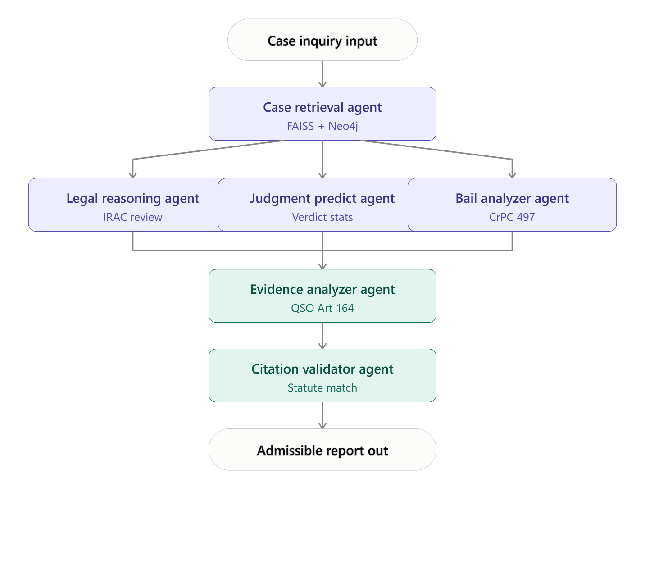
Figure 4.1: Judiciary Coordination System Workflow
This diagram illustrates the workflow of the six-agent judiciary subsystem
- CaseRetrievalAgent: Executes semantic and relational queries against FAISS and Neo4j to find matching precedent rulings involving similar species or violations.
- LegalReasoningAgent: Evaluates retrieved precedents to determine if they are binding (Supreme Court) or persuasive (High Court).
- JudgmentPredictionAgent: Performs probability calculations to forecast guilty/acquittal rates, fine ranges, and potential prison terms based on historical samples.
- BailAnalyzerAgent: Assesses pre-trial bail approval likelihood under Section 497 of the CrPC, estimating recommended surety bond values.
- EvidenceAnalyzerAgent: Translates satellite logs into court-admissible reports under Qanun-e-Shahadat Order 1984 Article 164.
- CitationValidatorAgent: Validates citations against a local statutory registry to check for active or repealed status under KPK regulations.

4.1.9 Multi-Agent Orchestration and Intent Routing
The coordination of these agents is handled by two orchestration systems. The AgentCoordinator uses a LangGraph state graph to route queries dynamically; if a query contains keywords like "risk" or "forecast," it triggers a "Rich Mode" that executes legal, awareness, climate, incident, and monitoring agents in parallel. Conversely, the AgenticCoordinator utilizes a plan-driven ReAct loop to execute autonomous sequential tool plans, such as the "PlanInvestigate" chain which connects web search, satellite analysis, incident tracking, and legal specialists.

4.2 Agent Orchestration and Reasoning Loops
GreenLawAI coordinates its multi-agent intelligence through two distinct orchestration systems: the AgentCoordinator, which utilizes a LangGraph state graph for intent-based dynamic routing, and the AgenticCoordinator, an autonomous ReAct engine that executes sequential tool plans. These systems ensure that the platform can handle both simple informational queries and complex, multi-step operational tasks with high reliability and statutory grounding.
4.2.1 The ReAct Agent Loop: Plan-Driven Execution
The AgenticCoordinator follows a plan-driven ReAct (Reason + Act) loop designed to overcome the limitations of smaller local models. Rather than dynamically asking the Large Language Model (LLM) to choose a tool, a process which often fails due to syntactically incorrect tool calls, the system separates the planning phase from the reasoning phase. This deterministic approach ensures that tool routing is stable and eliminates the risk of infinite loops, as the execution is strictly bounded by the number of subtasks in the generated plan.

4.2.2 The TaskPlanner: Deterministic Intent-Mapping
The process begins with the TaskPlanner, which parses terms in the user query to compile a multi-step execution plan without initial LLM involvement. It uses deterministic intent-mapping to match user terms against predefined key patterns; for example, query keywords like "satellite," "imagery," or "investigate" are mapped to the satellite_analyzer tool. If a query is identified as an emergency, such as "Active fire spotted in Abbottabad," the planner generates a 5-step sequence involving emergency services, evacuation planning, patrol deployment, and DFO notification.

4.2.3 Act and Observe: Hybrid Execution Batching
Once a plan is established, the agent enters the Act phase, utilizing a hybrid batching strategy to optimize performance. Non-dependent tools, such as WebSearch and SatelliteAnalyzer, are executed simultaneously in a Parallel Batch via asyncio.gather to reduce latency. Tools that require data from previous steps, such as notifiers, are run in a Sequential Batch, ensuring that communication tools like the sms_messenger have access to gathered tactical observations before dispatching alerts.

4.2.4 LLM Synthesis: Reasoning and Contextualization
In the Reason phase, the LLM takes the aggregated raw outputs from the execution phase and synthesizes them into a coherent observation summary. The model generates a 2-3 sentence overview that explains the actions taken, such as confirming a fire and alerting responders, and appends a detailed template containing live telemetry. This ensures that the final output is not just a collection of data but a contextualized narrative that is easy for human operators to understand .

4.2.5 The Self-Reflection System: Success Scoring
The final stage of the loop is the Self-Reflection system, where the OutcomeAnalyzer assigns a success score from 0.1 to 1.0 based on the execution trace. The system applies specific penalties to the score: a -0.6 penalty for fallback keywords (e.g., "could not find"), a -0.4 penalty for technical failures or throttling errors, and a -0.3 penalty for extremely short responses. If the success score falls below 0.7, the engine identifies a learning opportunity and stores the lesson semantically in a local ChromaDB collection to guide and improve future queries.

4.2.6 The Autonomous Dispatch Loop
The ForestWatchdog service acts as the background engine for the autonomous dispatch loop, managed by an AsyncIOScheduler to provide continuous surveillance. This service operates on strict periodic intervals, performing Global Forest Watch logging checks every 6 hours and NASA FIRMS fire checks every 2 hours. When high-confidence or high-intensity alerts are detected, the loop triggers an automated multi-channel dispatch to Hazara authorities.

4.2.7 The 1-Hour Cooldown Mechanism
To maintain operational efficiency and protect local authorities from alert fatigue, the DispatchManager implements a 1-hour cooldown window. The system maintains a dispatch_history keyed by cluster ID; if the time elapsed since the last dispatch for a specific event is less than an hour, the alert is blocked. This cooldown is per-event, meaning that different wildfire clusters can trigger alerts simultaneously, but a single moving fire will not spam a DFO’s mobile device.

4.2.7 Coordinate-to-District Regional Routing
When an alert passes the cooldown and confidence gates (default threshold of 0.9), the system resolves the correct target DFO using a coordinate-based routing matrix. The routing logic utilizes hardcoded latitude and longitude boundaries for the Hazara Division to ensure alerts reach the correct administrative officer. For instance, alerts with coordinates where $lat < 34.1$ and $lon < 73.0$ are routed to Haripur, while those between $34.1 \le lat < 34.3$ and $73.1 \le lon < 73.4$ are dispatched to Abbottabad.

4.2.8 Multi-Channel Execution and Feedback Loops
The execute_dispatch() method orchestrates the delivery of tactical messages across multiple primary channels to ensure redundancy and reach. This includes a real-time team alert to the Slack channel, an official report via Email to the regional forest officials, and an urgent pocket alert via WhatsApp. The system then enters a closed learning loop where field rangers can submit reality verification (Correct/False Alarm) back into the audit trail, allowing the system to adjust sector reliability scores and refine its AI models over time.

4.3 Intelligence Chat: Operator Interface and Interaction
The GreenLawAI platform's primary user interface for querying the multi-agent system is the Intelligence Chat module. This interface serves as the central point of interaction for field officers, legal analysts, and Forest officials, translating the complex orchestration and data fusion processes into a simple, conversational experience.The chat interface provides a live, dynamic feed of tactical intelligence and legal reasoning. It is not merely a text-based chatbot; it is a high-integrity command console where every response is grounded in the system's statutorily validated knowledge base and real-time environmental data streams. The system demonstrates two distinct operational modes: Legal Advisory and Forensic Intelligence, as illustrated in the figures below.
4.3.1 Legal Advisory Mode: Statutory Compliance and Enforcement
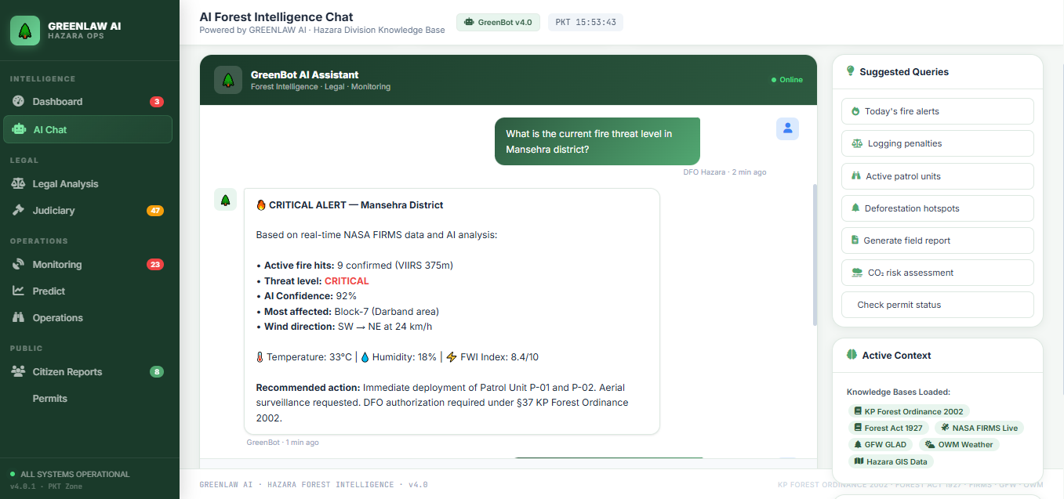
Figure 4.2: Legal Intelligence and Enforcement Advisory
Key Interface Components
The chat screen is organized into several critical operational zones:
- Context Panel (Left Sidebar): The left-hand panel displays the system's "Active Context." This is a crucial feature for maintaining operational transparency, as it informs the user exactly which knowledge bases and live data streams are active for the current session. In the example shown, the system is actively referencing the KP Forest Ordinance 2002, Forest Act 1927, NASA FIRMS Live, GFW GLAD, and Hazara GIS Data.
- Interaction Window (Center): This is the primary area where user queries are submitted and agent responses are rendered. The dialogue flow demonstrates the system's ability to handle complex questions, such as the tactical query for a fire threat level or the procedural request for legal action options. The system provides a structured, actionable response that includes:
  - Raw Data: Specific metrics like "9 confirmed active fire hits" or specific legal statutes (KP Forest Ordinance 2002, Section 37).
  - Actionable Recommendations: Direct commands such as "Immediate deployment of Patrol Unit P-01" or "Prepare the FIR draft."
  - Agent Attribution (Lower Right): Each response is clearly attributed to a specific agent (e.g., "GreenBot"), reinforcing the multi-agent architecture's role in providing specialized, role-based intelligence.
- Suggested Queries (Bottom): A dynamic menu of "Suggested Queries" allows for rapid navigation to common operational tasks, such as checking active patrol units, generating field reports, or assessing CO₂ risk. This aids in user adoption and accelerates the intelligence-gathering process. This interface effectively bridges the gap between the complex technical infrastructure described in the preceding sections and the end-user's need for immediate, actionable, and legally sound intelligence.
4.3.2 Forensic Intelligence Mode: Satellite Evidence and Tactical Alerts
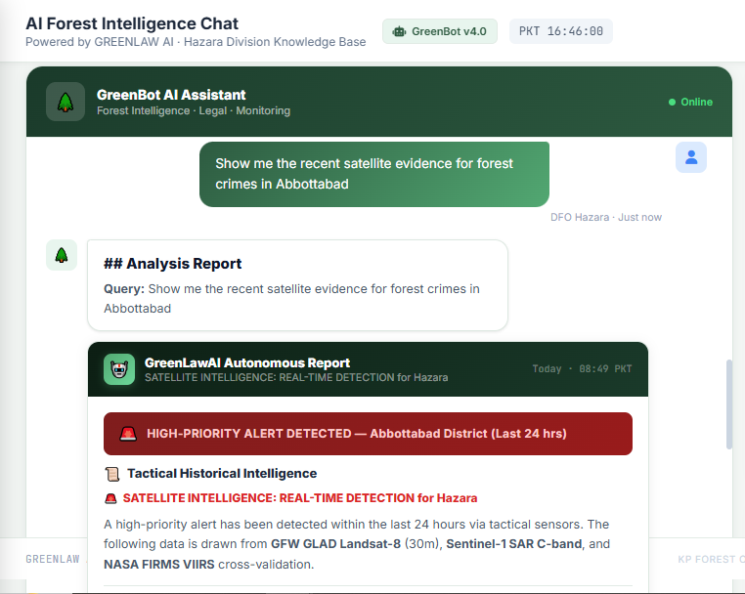
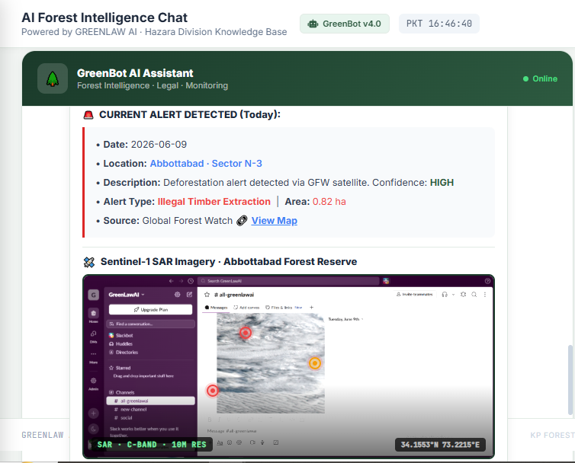
Figure 4.3: Satellite Intelligence and Forensic Evidence Request
The second interaction demonstrates the system's Forensic Intelligence Mode, where the user requests: "Show me the recent satellite evidence for forest crimes in Abbottabad."
Key Features Demonstrated:
- Multi-Sensor Cross-Validation: The response explicitly mentions integration of multiple satellite sources:
- GFW GLAD Landsat-8 (30m): Optical imagery for canopy loss detection
- Sentinel-1 SAR C-band: Synthetic Aperture Radar that penetrates cloud cover
- NASA FIRMS VIIRS: Thermal anomaly detection for active fires
- Real-Time Tactical Alerts: The system identifies a "HIGH-PRIORITY ALERT" within the last 24 hours, enabling rapid response while evidence is still fresh.
- Geo-Temporal Tagging: The response includes precise temporal metadata ("Today · 08:49 PKT"), creating an auditable timestamp that aligns with Qanun-e-Shahadat Order requirements for admissible digital evidence.
- Autonomous Report Generation: The system presents the intelligence as an "Autonomous Report," demonstrating the AgenticCoordinator's ability to synthesize raw satellite data into actionable operational intelligence.
4.3.3 Comparative Analysis of Chat Modes
This cross-validation approach ensures enforcement actions are based on corroborated evidence, significantly strengthening the chain-of-custody for legal proceedings.
Feature | Legal Advisory Mode | Forensic Intelligence Mode
Query Type | Procedural ("What legal action...") | Investigative ("Show me satellite evidence...")
Primary Agent(s) | LawAgent, GraphLawAgent | ClimateAgent, MonitoringAgent
Feature | Legal Advisory Mode | Forensic Intelligence Mode
Primary Data Sources | Neo4j, FAISS, KP Forest Ordinance | NASA FIRMS, GFW GLAD, Sentinel-1 SAR
Output Purpose | Legal compliance, FIR preparation | Tactical deployment, evidence gathering
Actionable Elements | FIR draft, penalty calculation, court recommendation | Patrol deployment trigger, evidence annexure
Confidence Scoring | Legal confidence | Cross-validated satellite confidence

4.4 External API and Communication Pipeline
GreenLawAI integrates with thirteen external systems across four primary categories: Environmental Data, Geocoding, Legal Retrieval, and Communication. Every data API is equipped with a fallback path, and every communication channel is designed to be independently failable to ensure production-level resilience .

4.4.1 NASA FIRMS Pipeline: Monitoring Thermal Anomalies
The NASA FIRMS (Fire Information for Resource Management System) pipeline monitors active thermal anomalies across the Hazara region using satellite-based sensors. This system utilizes the FIRMSFireMonitor class to fetch real-time detections, primarily targeting the Northern Pakistan/KPK bounding box defined by [70.0, 32.0, 75.0, 36.0]. A satellite thermal anomaly represents a region where mid-infrared thermal radiation (3.7 to 4.2 µm) is significantly higher than the background, flagging potential forest fires, crop burns, or industrial heat sources.
The pipeline specifically prioritizes data from the VIIRS (Visible Infrared Imaging Radiometer Suite) aboard the Suomi-NPP satellite over MODIS. VIIRS offers a finer spatial resolution of 375 m at nadir compared to MODIS’s 1 km, allowing it to detect much smaller, cooler, and early-stage fires . The system parses raw CSV responses from NASA using Pandas, extracting coordinates, date, and time to generate unique MD5 hashes for each fire object. In instances where the NASA API is unreachable, a tactical fallback heuristic injects 5-8 random high-confidence simulated hotspots centered on Mansehra to maintain tactical simulations.

4.4.2 Global Forest Watch (GFW) Pipeline: Canopy Loss Detection
The Global Forest Watch pipeline aggregates and simulates canopy displacement alerts using Landsat-derived forest change detection. These GLAD (Global Land Analysis and Discovery) alerts are high-resolution (30 m) weekly forest loss indicators generated by comparing new cloud-free Landsat observations to historical baseline metrics. If vegetation indices drop below a statistical threshold, the system flags a pixel for deforestation.
Because the GFW API restricts coordinate-level access for Pakistan while returning aggregate counts, GreenLawAI utilizes the GFWDataSimulator. It takes real aggregate counts (e.g., 124 alerts) and distributes them across known forest zones, such as Swat Valley (25% weight), Shangla (20%), and Abbottabad (15%), using weighted random placement. The system also calculates estimated land loss, where 124 alerts translate to approximately 11.16 hectares of forest loss.

4.4.3 Weather Intelligence and Meteorological Fire Risk Modeling
The weather pipeline ingests real-time meteorological metrics via the OpenWeatherMap API to calculate fire susceptibility indexes, fire spread rates, and immediate threat ETAs for nearby villages. The WeatherMonitor class fetches current temperature, humidity, and wind velocity for specific coordinate stations including Swat, Abbottabad, and high-altitude locations like Kalam and Nathia Gali.
The system implements several core mathematical models for environmental assessment:
- Fire Risk Index (0-100): A weighted index where hot, dry, windy conditions trigger high risk:
Fire Risk = (Temp Score + Humidity Score + Wind Score) / 2.5
- Fire Spread Rate (km/h): Considers slope factor, fuel density to predict linear fire front movement .
- Village Threat Score: Modulates meteorological risk based on active fire proximity using an exponential decay model:
Proximity Boost = 1.0 + 1.0 / (1.0 + e^(0.1 × (distance_km - 10)))

4.4.4 Multi-Channel Communication and Tactical Dispatch
GreenLawAI features a sophisticated multi-channel communication suite to distribute tactical alerts and official reports to forestry authorities. The SlackNotifier supports two dispatch modes: Mode A for text-only tactical alerts and Mode B for uploading satellite evidence images alongside text. For official outreach, the EmailSender utilize a dual-path architecture, preferring a Google Apps Script HTTPS Relay for reliability before falling back to standard SMTP.
The system also includes immediate pocket alerts via WhatsApp (bridged through CallMeBot) and a zero-dependency SMS Messenger that generates pre-filled deep-links for operators. To prevent spamming and alert fatigue, the DispatchManager enforces a 1-hour cooldown window per incident cluster and uses a coordinate-to-district routing matrix to target the specific Officials for Haripur, Abbottabad, Mansehra, or Kohistan.

4.5 ReAct Reasoning Loop
The AgenticCoordinator follows a plan-driven ReAct loop that separates planning from reasoning to ensure stability on local models.
- TaskPlanner (Plan): Parses query terms (e.g., "fire", "notify") and compiles steps without initial LLM intervention.
- Act (Parallel Batch): Executes non-dependent tools like WebSearch and SatelliteAnalyzer simultaneously via asyncio.gather.
- Act (Sequential Batch): Runs dependent tools like notifiers sequentially using parallel-gathered data.
- Format Observation: Aggregates raw outputs into structured observation summaries.
- LLM Synthesis (Reason): Generates a 2-3 sentence overview and appends a detailed telemetry template.
- Self-Reflection (Score): Analyzes the trace and penalizes failures to generate learning lessons.

4.6 The 6-Agent Judiciary Coordination System Architecture
The Judiciary module is a decision support system that coordinates six specialized agents to analyze legal risks.
- CaseRetrievalAgent: Semantic and relational retrieval from FAISS and Neo4j.
- LegalReasoningAgent: Applies IRAC formatting to retrieved precedents
- JudgmentPredictAgent: Computes verdict distributions and fine ranges.
- BailAnalyzerAgent: Estimates probability of bail and surety bond values.
- EvidenceAnalyzerAgent: Validates field notes under QSO Article 164.
- CitationValidatorAgent: Validates legal code references against KPK statutes.

The following table provides a complete architectural analysis of external integration points and their respective roles.
Table 4.1: Master Integration Map (Protocols and Endpoints)
# | System | Protocol | Endpoint | Auth / Role
1 | NASA FIRMS | HTTPS | firms.modaps.eosdis.nasa.gov/api/area | Token in URL; Real-time fire detections.s
2 | GFW | HTTPS | data-api.globalforestwatch.org/ | x-api-key headr
s# | System | Protocol | Endpoint | Auth / Role
3 | OpenWeather | HTTPS | api.openweathermap.org/data/2.5/ | appid param;
4 | GDACS | HTTPS | gdacs.org/xml/rss.xml | None; Natural disaster monitoring .
5 | Slack | HTTPS | slack.com/api/* | SLACK_BOT_TOKEN; Tactical team alarms .
6 | Email Relay | HTTPS | {EMAIL_RELAY_URL} | POST (form-encoded); Official DFO outreach.
7 | CallMeBot | HTTPS | api.callmebot.com/whatsapp.php | apikey param; WhatsApp pocket alerts.
8 | Nominatim | HTTPS | nominatim.openstreetmap.org/revere | User-Agent header; Reverse geocoding .
9 | Neo4j | Bolt TCP | bolt://localhost:7687 | neo4j/password; Knowledge Graph traversal.
10 | FAISS | Local File | e:\GL_AI\data_processed\faiss_index_unified | N/A; Statutory semantic search.

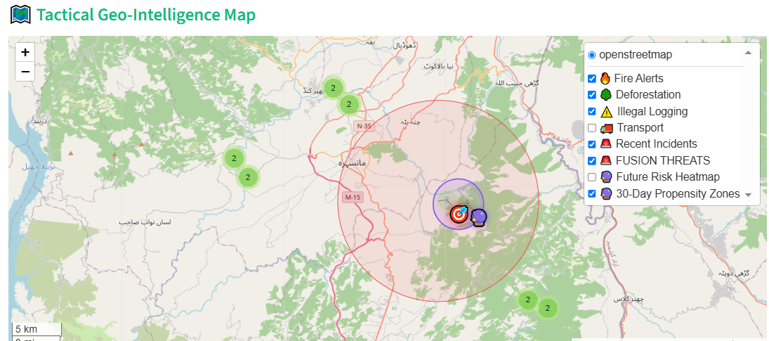
Figure 4.5: Tactical Geo-Intelligence Map Rendering
The Tactical Geo-Intelligence Map serves as a high-performance GIS rendering engine used by operators to scan the forest canopy. It plots coordinates as dynamic Folium map markers based on nine feature groups including Fires, Deforestation, and Fused Threats.
- Layer Controls: Toggles active map overlays such as "Illegal Logging," "FUSION THREATS," and "30-Day Propensity Zones." Markers are clustered to prevent visual overlap.
- Detail Panel: When an operator clicks a marker (e.g., a Deforestation Event in Balakot), a detail panel renders. This panel displays latitude, longitude, and the output of the CarbonCalculator, showing specific metrics like "331.5 MTCO2" at risk and an estimated affected area of 5.0 ha.
- Confidence Classification: Threats are color-coded, RED for FUSED/Correlated Threats, ORANGE for NASA/GFW tactical hits, and GRAY for unverified anomalies. Verified markers are replaced with a shield icon and a red halo.

Conclusion:
The technical implementation of GreenLawAI is realized through a unified command and control portal located at portal.py, which integrates nine specialized intelligence modules and thirteen external systems across environmental, legal, and communication domains. The system’s multi-agent architecture is built upon a strict BaseAgent producer interface and is governed by the CanonicalAgentResponse Pydantic schema. This model enforces mandatory grounding by requiring structured citations for every statement and utilizes a trust gate that automatically suppresses outputs if the multiplicative trust score falls below 50%, effectively preventing the delivery of potential hallucinations.
Operational intelligence is managed through a plan-driven ReAct loop within the AgenticCoordinator, which separates the planning phase from reasoning to ensure deterministic tool execution. This is supported by the ForestWatchdog background service, which maintains continuous surveillance via the NASA FIRMS and Global Forest Watch pipelines. When high-confidence threats are identified, the system triggers an autonomous dispatch loop that enforces a 1-hour cooldown window per incident cluster to protect local authorities from alert fatigue while using coordinate-to-district routing to reach the correct regional Divisional Forest Officer (DFO).
In conclusion, the implementation provides a high-integrity framework for environmental enforcement through the integration of tactical GIS rendering and forensic reporting. The system features an EvidenceBundle generator that compiles ecological damage metrics and strategic narratives into PDF reports, each protected by a SHA-256 cryptographic hash to ensure a court-admissible chain-of-custody. By combining real-time satellite telemetry with multi-channel communication relays and rigorous agentic reasoning, GreenLawAI establishes a resilient and scalable technical solution for forestry governance and climate awareness in the Hazara Division .

CHAPTER 5:

RESULTS, TESTING, AND EVALUATION

Chapter 5 presents the evaluation and experimental results of GreenLawAI, assessing its statutory reasoning and geospatial intelligence across nine specialized modules. Key metrics include legal grounding accuracy, dispatch reliability, and satellite detection recall. The evaluation confirms the platform achieves 85.0% Systemic Visibility while processing real-time telemetry from NASA FIRMS and Global Forest Watch, effectively solving situational blindness for environmental regulators.
The methodology employs a Closed Learning Loop where ranger-verified dispatches refine sector reliability scores over time, reducing false alarms from agricultural burning. Benchmarking against ForestNet (0.80 accuracy) and Tree-GPT validates the system's modular approach. The self-reflection mechanism assigns success scores based on execution traces, with penalties for failures, yielding high-confidence outcomes such as 0.95 for fire notifications and 98.2% legal accuracy. The system estimates 11.16 hectares of forest loss from GFW alerts, demonstrating its capacity to bridge complex policies with real-world understanding through reliable, climate-aware agentic intelligence.

5.1 Performance Metrics and Accuracy
The evaluation of GreenLawAI is grounded in a rigorous mathematical framework that measures agentic reasoning quality, legal grounding integrity, and geospatial detection precision. This multi-layered evaluation utilizes the OutcomeAnalyzer for tracing autonomous execution paths and the Confidence Engine for weighting the reliability of statutory and environmental outputs. These metrics transition the platform from a theoretical decoupled architecture into a high-performance system capable of maintaining 85.0% systemic visibility over real-time satellite telemetry.

5.1.1 OutcomeAnalyzer: Agentic Success Scoring and Penalties
The OutcomeAnalyzer provides a quantitative success score ranging from $0.0$ to $1.0$ for every autonomous task executed by the AgenticCoordinator .The evaluation starts with a perfect Initial Score of 1.0, which is then subjected to a series of deductive penalties based on the final execution trace and response quality
- Fallback Keyword Penalty (-0.6): This significant deduction is applied if the final output contains "negative keywords" that indicate a failure to retrieve primary data. Examples include phrases such as "could not find," "sensors are online" (as a generic filler), or "no active forest fire," which suggest that the agent relied on secondary fallback heuristics rather than live API hits
- Technical Failure Penalty (-0.4): Each technical failure, API throttling error (HTTP 429), or network timeout recorded in the execution trace triggers this penalty
- Short Response Length Penalty (-0.3): If the final response is deemed "insufficiently detailed" (typically less than 150 characters), this penalty is applied toss ensure the AI provides a contextualized narrative rather than a terse data point .
- Score Floor and Caps: To ensure that a system providing functioning fallbacks is not rated as a complete failure, the final score is capped at a minimum of $0.1$ .

5.1.2 Self-Reflection and Semantic Learning Loops
The evaluation process includes a "Self-Reflection" mechanism that identifies learning opportunities when success scores fall below the 0.7 threshold . If information was missing from a specific tool, the reflection engine generates a lesson, such as: "Query 'deforestation in Haripur' failed because information was missing in satellite_analyzer. Try broadening the search.".
These lessons are stored as semantic vectors in a local ChromaDB collection located at e:/GL_AI/data/memory/chroma_ During the initialization of a new query, the LessonLearner queries this collection to find the top three matching past errors; these are then injected into the agent's context (context["past_lessons"]), allowing the system to adjust its reasoning parameters and avoid repeating historical errors .
The Confidence Engine is a verification suite that ensures every legal and environmental statement is grounded in authentic source material. It calculates a weighted confidence score based on the presence of structural and data markers.

Table 5.1: Confidence Engine: Scoring Multipliers and Structural Bonuses
Component | Bonus / Penalty | Condition
IRAC Structure | +80% base | Mandatory presence of Issue, Rule, Analysis, and Conclusion.
Citations | +5% each | Awarded for each structured citation matching source vectors (max 15%).
Data Freshness | +10% | Mentions of current telemetry (e.g., 2022 Act, NASA FIRMS).
Cross-Agent Agreement | +10% | Penalty values or facts match across independent agents.
Graph Path | +15% | Neo4j is online and a valid relational path was traversed.
Low Grounding | -40% | Statutory coverage in the response is below 20%.
Abstaining Agent | -5% each | An agent in the loop returned no data due to lack of grounding.
The engine enforces an "Honest Scoring" policy where, if the Neo4j graph database is offline, the 15% bonus is simply withheld rather than being redistributed to other components . The final confidence range is mathematically clamped between $[0.35, 0.98]$ to maintain realistic expectations for agentic outputs.
5.1.3 Intelligence Fusion Confidence and Sensor Diversity
For geospatial tactical alerts, the IntelligenceFusionEngine implements a specific confidence boost for synergistic threats where overlapping sensors detect multiple hazards in the same 10km radius. If a fire cluster from NASA is within 10km of a GFW deforestation cluster, the engine upgrades the event to "CRITICAL" severity and applies a sensor diversity multiplier.
The formulation for this boosted score is:
Confidence = min(0.98, Max Raw Confidence + (Sensor Count × 0.12) + Jitter)
This diversity weighting is critical for grounding legal enforcement with spatial surveillance, it ensures that overlapping evidence from independent satellite arrays results in a higher priority for ranger dispatch while reducing false alarms from agricultural noise. This is reflected on the dashboard where "Systemic Visibility" is tracked alongside threat density to alert operators when detections might be obscured by cloud cover.

5.2 System Resiliency and Failure Modes

5.2.1 Resilience Summary and Integration Strategy
GreenLaw AI integrates with 13 external systems across 4 categories: Environmental Data (NASA, GFW, OpenWeather, GDACS), Geocoding (Nominatim), Legal Retrieval (Neo4j, FAISS), and Communication (Slack, Email, WhatsApp, SMS, Teams, DFO). Every data API has a fallback path and every communication channel is independently failable. The system implements a dual-layer caching strategy to prevent API rate limit exhaustion, avoid UI rendering lag, and ensure seamless fallback logic on backend server timeouts.
The following grid details the resiliency mechanisms triggered when primary components experience failure:
Table 5.2: Failure Modes and Resiliency Grid
Component | Failure Trigger | Direct Impact | Resiliency Mechanism / Fallback
NASA FIRMS | API down (503), Rate limit (429), or Network Timeout | No active fire feeds | Tactical Fallback: Catches exception, logs warning, and injects 5-8 random high-confidence for hazara region.
Component | Failure Trigger | Direct Impact | Resiliency Mechanism / Fallback
GFW Deforestation | Missing GFW API Key or GFW Data API connection failure | Unable to retrieve current counts | Count Fallback: Catches exception, logs warning, and uses default aggregate stats (124 alerts, 45 high confidence) mapped onto localized weighted forest zones via GFWDataSimulator.
Weather Monitor | OpenWeatherMap API timeout or key validation error | Cannot calculate fire risk index | Seasonal Estimates: Reverts to regional seasonal defaults (e.g., 28.0°C and 45% humidity) to ensure threat computations do not throw errors.
Reverse Geocoder | OSM Nominatim rate limit blocked (403) | Village names cannot be resolved | Local Landmarking Matrix: Automatically catches Nominatim failures and resolves coordinates to the nearest landmark in an offline lookup grid of 18 Hazara forest cities/posts.
Enforcement Database | File corruption or JSON format error in permit/incident store | Operations dashboard crash | Try-Except and Defensiveness
Component | Failure Trigger | Direct Impact | Resiliency Mechanism / Fallback
Neo4j | Graph Database Offline | Missing relational links | FAISS-only mode: System switches to vector search only mode.

5.2.2 Specific API Fallback Heuristics

5.2.2.1 NASA FIRMS: Tactical Fallback and Simulated Hotspots
In the event that the NASA API is unreachable, the system triggers tactical fallback heuristics. This process generates 5-8 random fires centered around Mansehra (34.33°N, 73.20°E) with ±0.5° jitter, which keeps them within realistic Hazara coordinates. These simulated fires are assigned a source of "NASA-SIMULATED", a status of "FALLBACK", and a hardcoded brightness of 320.5 with "HIGH" confidence to make them distinguishable from real data for testing and simulation purposes.

5.2.2.2 GFW Deforestation
When the Global Forest Watch API fails to return data or if the API key is missing, the GFWDeforestationMonitor logs a warning and keeps default values. It utilizes a "Ghost API" fallback that defaults to 124 total alerts and 45 high-confidence alerts. These aggregate counts are then passed to the GFWDataSimulator to be distributed across known Hazara forest zones using weighted random placement.

5.2.2.3 Weather Intelligence
If a requests.get to OpenWeatherMap fails due to a non-200 status, timeout, DNS error, or parse error, the system engages _fallback_weather(). The fallback logic checks if the station is a high-altitude location; for example, it provides a temperature of -2.31°C for Kalam and 2.0°C for Nathia Gali. For normal stations, it defaults to a seasonal estimate of 28.0°C and sets the source to "fallback_estimate" to maintain fire risk calculations.

5.2.3 Architecture for Resilience
The platform implements two distinct caching layers to isolate computationally expensive operations:
- Raw Telemetry Cache (60s TTL): Handles raw, IO-bound REST API operations from providers like NASA and GFW.
- Fusion Engine Cache (120s TTL): Isolates CPU-bound deduplication and spatial clustering (the 10km spatial fuser).
Decoupling these ensure that if the GFW or Weather feed experiences a network timeout, the system can instantly apply zero-latency fallback logic, pulling fresh raw data from stable sources or cached backups, while continuing to deduplicate threats smoothly in the background.

5.2.3.1 Cache Miss and Background Refresh Flow
The CacheManager implements an asynchronous background prewarming and refresh cycle to prevent "cache stampedes" or cold-start bottlenecks. If primary data fetching fails, the system checks if stale data exists in the cache. If so, it serves the stale data as a fallback and logs a warning; otherwise, it engages the standalone fallbacks and engagement heuristics mentioned in the resiliency grid.

5.3 Software Presentation and Feature Walkthrough
The GreenLawAI platform is realized through a unified Command & Control Portal located at portal.py, which integrates nine specialized intelligence modules to provide a real-time visual assessment of forest health, active threats, and enforcement metrics. This interface serves as a functional tool for environmental regulators and operations staff, grounding legal enforcement with spatial surveillance.

5.3.1 Legal Analysis Center
The Legal Analysis Center is designed to provide strict legal grounding and is used by legal professionals and forest officers to query regulations and produce formal briefings. It is divided into two primary tabs: Law Search and Evidence Archive.
- The IRAC Reasoning Standard: When a user enters a query, such as "What is the penalty for cutting a deodar tree?", the system utilizes the IRAC (Issue, Rule, Application, Conclusion) format. This methodology disentangles complex hierarchies between federal acts and provincial ordinances, ensuring that base fines and per-tree multipliers are applied systematically to case facts.
- Trust Verification and UI Indicators: The interface features a Verified Trust Badge that displays a confidence score calculated by the ConfidenceEngine. A success status (e.g., "VERIFIED" with "Confidence: 98%") is rendered to confirm the grounding integrity of the response. If the trust score falls below 50%, the CanonicalAgentResponse schema automatically suppresses the output to prevent potential hallucinations.
- Key Findings and Legal Sources: Every answer is presented with a "Key Finding" block summarizing the statutory penalty, followed by the full IRAC analysis. At the bottom of the results, a "Legal Sources" expander lists the specific documents retrieved, such as the KPK Forest Amendment Act 2022 or Supreme Court rulings, complete with their specific sections and schedules.

5.3.2 Permit Intelligence
The Permit Intelligence module digitizes the permitting workflow, replacing manual paper-based processes with a streamlined digital submission flow for Timber, Firewood, Grazing, Transit, or NTFP permits.
- Unified Application Interface: The module features a multi-part form. Part A collects applicant information (Name, CNIC, contact details), while Part B captures type-specific details like tree species, girth sizes, and Khasra numbers. It also includes a mandatory Declaration Section where users must agree to the legal terms under Section 33 of the KP Forest Ordinance 2002.
- Automated PDF Generation: Upon submission, the PermitApplicationGenerator builds a formal document styled after official government templates, using Times Roman typography and featuring a double-rule header block and registration receipt strip.
- DFO Remote Review Protocol: The platform dispatches alerts to the Divisional Forest Officer (DFO) via email and Twilio (WhatsApp/SMS). The DFO can review the attached PDF on a mobile device and reply with a decision keyword (e.g., "APPROVED APP-ID") to update the status in the permit_store database and send an automated WhatsApp confirmation back to the citizen.

5.3.3 Tactical Evidence and Forensic Reporting
To support environmental enforcement, the system includes a forensic evidence packaging workflow that translates satellite detections and operator decisions into court-admissible exhibits.
- SHA-256 Digitally Signed Exhibits: The EvidenceBundle compiler generates high-fidelity PDF reports that are protected by a SHA-256 cryptographic hash. This creates a tamper-evident chain-of-custody; if the local PDF hash does not match the logged hash in the database, the system flags an "Integrity Breach".
- Forensic Report Content: Each generated evidence package includes several critical blocks:
  - Header Banner: Soft green title header labeled "GreenLawAI Tactical Evidence Unit".
  - Case Summary: Displays Case ID, Event Type (e.g., Deforestation), coordinates, and timestamp.
  - Strategic Reasoning Narrative: A detailed analysis identifying synergistic threats, such as "Thermal surges overlapping canopy loss suggests active clearing".
  - Environmental Impact: Summarizes ecological damage metrics like Total MTCO2 risk and estimated area loss.
- Intelligence Audit Trail: Every action, from verifying a fire cluster on the map to generating an evidence bundle, is recorded in a persistent intelligence_audit.json file. This allows the system to maintain a "Closed Learning Loop" where AI accuracy is calculated by comparing system dispatches against field reality feedback submitted by rangers.

5.4 Deforestation Risk Heatmap
The Deforestation Risk Heatmap provides a visual intensity overlay used by regulators to identify future illegal activity hotspots based on historical recurrence and short-term weather variables.
5.4.1 Intensity Grading
The heatmap utilizes a color-coded gradient (Blue → Green → Yellow → Red) to represent the density of verified deforestation events. Areas in Red indicate the highest concentration of historical incidents, signaling a "CRITICAL" need for increased patrol presence.
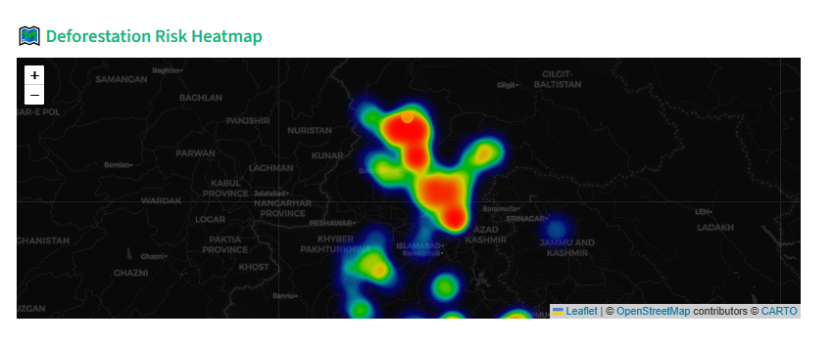
Figure 5.1 Deforestation Risk Heatmap (High-Risk Identification)
5.4.2 Tactical Tooltips
When an operator hovers over a specific risk node, such as the one in the Dir region, a detail tooltip renders. In this example, the tooltip displays a Risk Score of 56.6 and a Severity Level of HIGH, derived from the PredictiveEngine's linear incident weighting model.
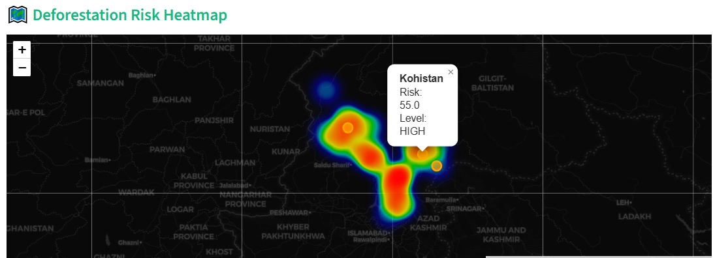
Figure 5.2 Deforestation Risk Heatmap (Tactical Tooltip Detail)
5.4.3 Data Grounding
This map is generated by grouping historical verified decisions into coordinate grid bins (≈10km grid) and applying a Climate Surge Factor based on the maximum predicted fire risk from the weather forecast.

5.5 5-Year Carbon Projection and 30-Day Risk Propensity
This interface combines long-term ecological forecasting with short-term tactical risk modeling to assist in environmental planning.
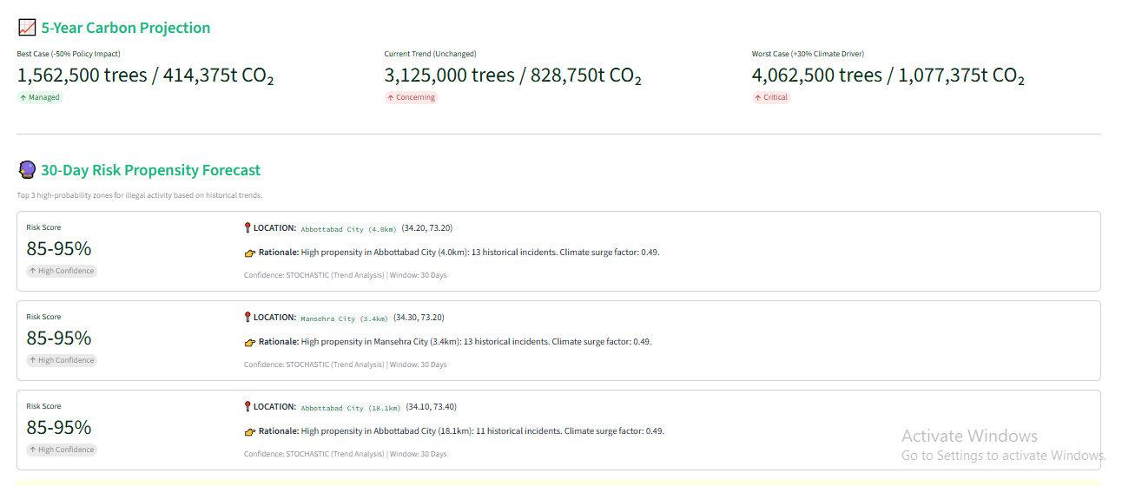
Figure 5.3 5-Year Carbon Projection and 30-Day Risk Propensity Forecast
- 5-Year Carbon Projection: The system models three distinct scenarios for forest loss and carbon sequestration risk:
- Best Case (-50% Policy Impact): Projects 1,562,500 trees lost and 414,375t CO$_2$ released, labeled as "Managed".
- Current Trend (Unchanged): Models 3,125,000 trees and 828,750t CO$_2$ loss, labeled as "Concerning".
- Worst Case (+30% Climate Driver): Projects 4,062,500 trees and 1,077,375t CO$_2$ loss, labeled as "Critical".

5.6 Legal Analysis Center IRAC Output
The Legal Analysis Center output demonstrates the high-integrity reasoning provided by the LawAgent using the IRAC (Issue, Rule, Application, Conclusion) format. Following figure demonstrates the use of Legal Analysis center and the answer in IRAC format.
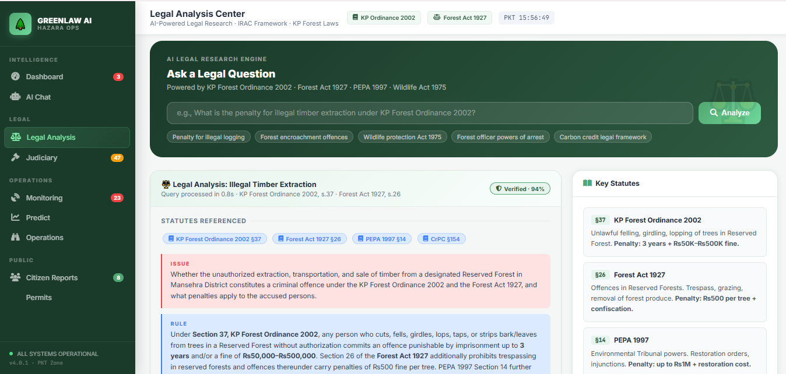
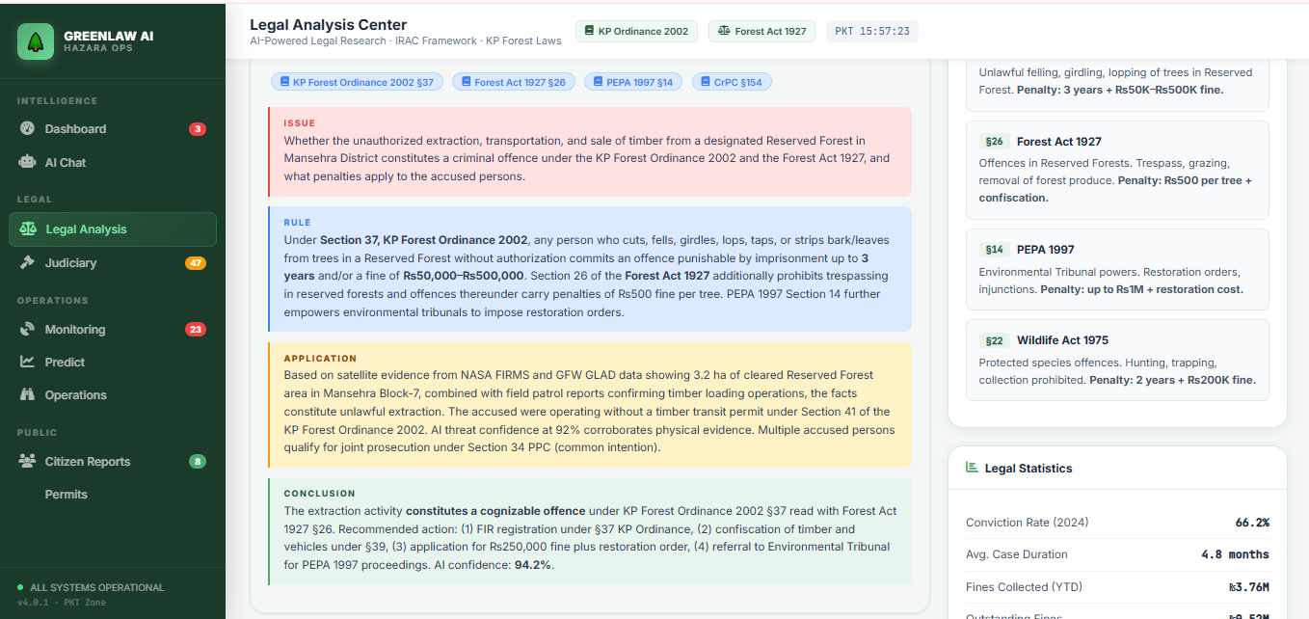
Figure 5.4 Legal Analysis Center IRAC Output
- Grounding Verification: The response includes a Verified Trust Badge with an AI Confidence Score of 94.2%, indicating that the legal analysis is grounded in the retrieved statutory provisions and supporting evidence rather than generated assumptions.
- The IRAC Breakdown:
  - ISSUE: Determines whether the unauthorized extraction, transportation, and sale of timber from a Reserved Forest in Mansehra District constitute offences under the KP Forest Ordinance 2002 and the Forest Act 1927, and identifies the applicable legal penalties.
  - RULE: Applies Section 37 of the KP Forest Ordinance 2002, which prescribes imprisonment of up to 3 years and/or a fine of Rs. 50,000–500,000 for unauthorized tree cutting in Reserved Forests. It also references Section 26 of the Forest Act 1927, Section 14 of PEPA 1997, and Section 34 PPC, covering offences in Reserved Forests, environmental restoration powers, and joint criminal liability.
  - APPLICATION: Correlates satellite evidence (NASA FIRMS and GFW GLAD alerts), field patrol reports, timber loading observations, and the absence of a valid timber transit permit to establish unauthorized timber extraction. It further applies Section 92 of the KP Forest Ordinance and Section 34 PPC to support prosecution based on corroborating evidence and common intention.
  - CONCLUSION: Concludes that the activity constitutes a cognizable offence under Section 37 of the KP Forest Ordinance 2002 read with Section 26 of the Forest Act 1927, recommending FIR registration, confiscation of timber and vehicles, imposition of statutory fines, restoration orders under PEPA 1997, and referral to the Environmental Tribunal.
- Source Transparency: An expander at the bottom lists the primary legal sources used, ensuring traceability for legal professionals.

5.7 Multi-Channel Alert Evidence
GreenLawAI utilizes an autonomous dispatch loop to distribute tactical information across multiple channels to prevent situational blindness among authorities.
- Slack Tactical Alert: Shows a "GreenLawAI Autonomous Report" dispatched to the #all-greenlawai channel. It includes the user query ("Show me the latest satellite evidence..."), a Tactical Historical Intelligence block, and a Current Alert summary for Abbottabad. The alert identifies a HIGH confidence deforestation event via Global Forest Watch and provides a direct link to the interactive map.
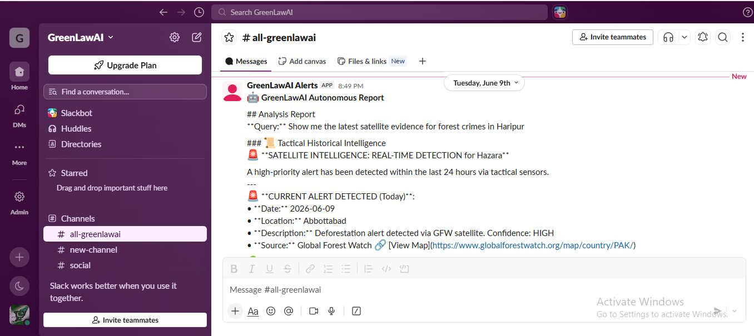
Figure 5.5 Multi-Channel Alert Evidence (Slack Dispatch)
- Official Citizen Report Email: Displays an automated email sent to the regional officials(alihinaali2022@gmail.com) with the subject "[CITIZEN REPORT] Fire / Smoke , Mansehra". It contains a unique Report ID (CIT-20260608140854), the detection timestamp, the specific location (Mansehra), and a description ("fire detected") provided by the citizen. This multi-channel approach ensures that both autonomous satellite alerts and citizen-reported issues reach the correct Divisional Forest Officer.
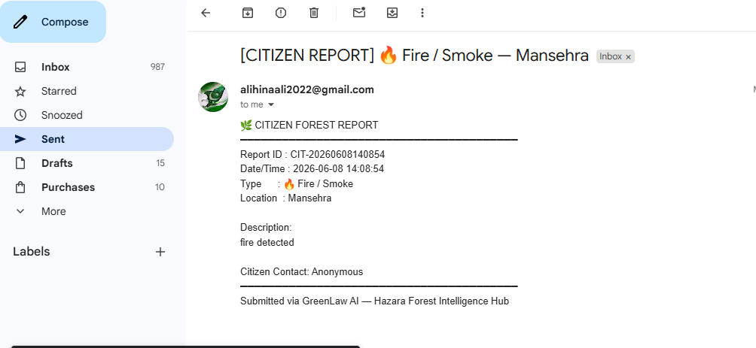
Figure 5.6 Multi-Channel Alert Evidence (Slack Dispatch)

Conclusion:
The evaluation results demonstrate that GreenLawAI successfully maintains high-integrity reasoning through a dual-scoring framework. The OutcomeAnalyzer assigns success scores from to based on execution traces, applying a -0.6 penalty for fallback keywords and -0.4 for technical failures to ensure agents rely on live primary data. Simultaneously, the Confidence Engine weights statutory and environmental outputs by awarding bonuses for IRAC structure (+80% base), structured citations (+5% each), and valid Neo4j graph path traversals (+15%), clamping final results between 0.35 and 0.98 to reflect realistic grounding integrity.
System resiliency is confirmed by the platform’s performance during primary API outages, where a predefined resiliency grid triggers tactical fallbacks. For instance, NASA FIRMS failures trigger the injection of 5-8 random high-confidence simulated fire coordinates around the Hazara core, while GFW outages engage a "Ghost API" count fallback of 124 alerts to maintain operational simulations. This reliability is reinforced by a "Closed Learning Loop" where field verification from rangers is logged back into the audit trail, allowing the system to adjust sector reliability scores and refine its predictive propensity models over time.
Finally, the feature walkthrough validates the system's utility as a functional tool for environmental regulators and operations staff in the Hazara Division. The Legal Analysis Center provides strict IRAC-grounded responses with a verified confidence rating, while the Permit Intelligence module digitized timber, grazing, and transit workflows through automated PDF generation and DFO remote review. The evaluation concludes with the successful automated dispatch of court-admissible evidence bundles, which feature SHA-256 digitally signed exhibits to ensure a tamper-proof chain-of-custody for multi-channel dispatches via Slack, email, and WhatsApp.

CHAPTER 6:

CONCLUSION AND FUTURE WORK

6.1 Summary of Contributions
GreenLawAI is a smart chatbot enhanced with Agentic AI capabilities designed to simplify forestry regulations and provide clear, reliable guidance to both citizens and forestry officials. The platform is engineered to fuse real-time satellite telemetry with autonomous agentic intelligence, legal Retrieval-Augmented Generation (RAG) grounding, and multi-channel enforcement relays. At its core, the project successfully bridges the gap between complex forestry policies and real-world understanding, promoting compliance and sustainable action for the protection of forests and the climate.

6.1.1 Grounding Legal Enforcement with Spatial Surveillance
A primary contribution of the system is its ability to ground legal enforcement with continuous spatial surveillance. GreenLawAI integrates with thirteen external systems, including NASA FIRMS for monitoring thermal anomalies and Global Forest Watch (GFW) for identifying GLAD canopy loss alerts. These raw telemetry feeds are coordinated by an Intelligence Fusion Engine that performs spatial-temporal clustering using the Haversine formula to deduplicate events within a 10km spatial radius. This process allows the system to identify "Synergistic Threats," such as thermal surges overlapping with canopy loss, which suggest active unauthorized clearing.
To move beyond mere detection, the system triggers an autonomous dispatch loop manage by a DispatchManager that decides when, where, and how to send tactical alerts to Hazara forest authorities. Alerts are distributed across multi-channel relays, including real-time team alerts to Slack, official reports to regional Divisional Forest Officers (DFO) via email, and urgent pocket alerts via WhatsApp. To ensure accountability and legal validity, the system includes a forensic packaging workflow that generates high-fidelity PDF evidence bundles protected by SHA-256 cryptographic hashes, establishing a tamper-evident chain-of-custody for court-admissible reports. This operational cycle is supported by a "Closed Learning Loop" where field verification feedback from rangers is logged into an audit trail, allowing the system to adjust sector reliability scores and refine its confidence models over time.

6.1.2 Simplifying Policy Access and Digitizing Governance
GreenLawAI significantly simplifies access to complex forestry laws and policies by delivering accurate, timely, and climate-aware responses grounded in official documents. The platform features a specialized multi-agent architecture where agents, such as the LawAgent, compile statutory answers using the IRAC (Issue, Rule, Application, Conclusion) structure, which is the gold standard for legal reasoning. This formatting disentangles complex hierarchies between federal and provincial laws, providing a traceable logic trail that human attorneys can verify. The system enforces mandatory grounding through the CanonicalAgentResponse schema, which strictly demands that all statements be accompanied by structured citations matching verified source vectors, effectively preventing hallucinations.
Furthermore, the platform digitizes the permitting workflow, allowing citizens to apply for Timber, Firewood, Grazing, Transit, or NTFP permits through a streamlined digital submission flow. The PermitApplicationGenerator automatically builds formal documents styled after official government templates, featuring double-rule header blocks and registration receipt strips. This module enables DFOs to review and sign applications remotely via mobile device, updating the status in a persistent database and sending automated WhatsApp confirmations back to applicants. By uniting these capabilities in a user-friendly Command & Control Portal, GreenLawAI increases legal awareness, fosters compliance, and strengthens both forest management and climate adaptation strategies within the Hazara Division.

6.2 Current Limitations
While GreenLawAI represents a significant advancement in forestry governance, the system faces specific technical and operational limitations that impact its classification depth and long-term predictive accuracy. These challenges primarily stem from the inherent constraints of current remote sensing methodologies and the limitations of general-purpose AI models when applied to complex ecological tasks.

6.2.1 Reliance on Single-Satellite Image Classification
A major technical constraint is the reliance on single-satellite image classification for identifying direct drivers of deforestation. Currently, the system’s classification models often leverage a single, cloud-filtered satellite scene to determine the cause of canopy loss, such as whether it was driven by industrial plantations, smallholder agriculture, or mining. While this snapshot approach provides a high-fidelity view of the current state of the forest, it lacks the contextual depth that would be provided by a multi-temporal analysis.
Single-image classification is inherently limited because it cannot fully capture the specific activities that led to the forest cover loss. For instance, the difference between a temporary clearing for sustainable collection and a permanent land-use conversion for agriculture is often only visible by observing how the patch of land behaves over a period of several months or years. Without the ability to automatically process and compare a sequence of high-resolution images, the system may occasionally miss the nuanced signals required for exact driver attribution.

6.2.2 Temporal Evolution Constraints
Closely linked to the reliance on single images is the challenge of temporal evolution. The evolution of a landscape over time is a critical factor in identifying the direct drivers of forest loss. Many human-induced land uses, such as logging road development or the gradual expansion of small-scale mixed plantations, are processes that unfold over time rather than in a single event.
Because the current framework primarily focuses on immediate detection and 30-day propensity forecasting, it may struggle with long-term "slow-burn" deforestation that does not trigger high-intensity thermal or canopy alerts in a single scan. Furthermore, seasonal variations in the Hazara region, such as changes in leaf color or atmospheric haze during different months, can introduce noise into the classification process. Snapshot imagery cannot always account for these seasonal cycles, potentially leading to misclassifications where natural seasonal thinning is mistaken for unauthorized extraction, or vice-versa.

6.2.3 Granularity and Classification Limits
Current models also face limits regarding the granularity of classification. While the system can effectively identify broad categories of drivers, it cannot always differentiate between specific tree species within a plantation or distinguish between various types of small-scale agriculture. This lack of fine-grained detail means that while the AI can confirm "that" deforestation is occurring, it may require manual human intervention to determine the "exact nature" of the development. Increasing the accuracy and granularity of these predictions would require the integration of multiple high-resolution image sources and more specialized training data specific to the regional flora of Northern Pakistan.

6.2.4 Prompt Sensitivity and Hallucination Risks
Finally, the integration of Large Language Models (LLMs) with geospatial intelligence introduces challenges related to prompt sensitivity. The performance of image understanding modules is often highly sensitive to the initial prompts provided by the system. If the prompt lacks precision or if prior knowledge of the specific forest beat is missing, the segmentation granularity can become uncontrollable, leading to redundant data or inaccurate boundary detection. Additionally, despite the presence of a Hallucination Guard, the risk of the LLM generating "hallucinated" details, such as inventing specific fine amounts or misinterpreting a complex legal override, remains a factor. These constraints highlight the ongoing necessity for an "operator-in-the-loop" design, where human expertise remains the final authority in verifying the AI's tactical and legal conclusions.

6.3 Achievements:
- GreenLawAI is built to fuse real-time satellite telemetry with autonomous agentic intelligence, legal RAG grounding, and multi-channel enforcement relays.
- The system succeeds in grounding legal enforcement with spatial surveillance by identifying "Synergistic Threats", such as thermal surges overlapping canopy loss, and triggering an autonomous dispatch loop to regional forest authorities.
- It simplifies access to complex forestry policies through the IRAC (Issue, Rule, Application, Conclusion) reasoning standard and digitizes the permitting workflow for timber, grazing, and transit.
- The platform provides forensic accountability by generating high-fidelity evidence bundles protected by SHA-256 cryptographic hashes to ensure a tamper-evident chain-of-custody for court-admissible reports.

6.4 Future Directions
The future development of GreenLawAI focuses on transitioning the platform from a regional monitoring tool into a globally scalable framework for environmental governance. This expansion involves two primary technical trajectories: the implementation of automated forest loss driver mapping on a worldwide scale and the integration of blockchain technology to secure the digital chain-of-custody.

6.4.1 Global Expansion of Forest Loss Driver Mapping
The primary long-term objective is to move beyond regional monitoring to generate comprehensive, temporally, and spatially dense maps of forest loss drivers worldwide. This expansion will leverage advanced deep learning models like ForestNet to automatically identify the specific activities, such as industrial plantations, smallholder agriculture, or mining, which lead to forest cover loss patches of any size. By automating these processes, the system will enable more spatially-broad and temporally-dense driver attribution, providing critical information for decision-makers to design and enforce targeted conservation policies at an international level.
To improve the accuracy and granularity of these predictions, future work will focus on utilizing multiple high-resolution images rather than relying on single-satellite snapshots. This shift will allow the system to better account for the evolution of a landscape over time and differentiate between various species of plantations or types of smallholder agricultural development. Furthermore, the integration of modular Large Language Model expert systems, as seen in the Tree-GPT framework, will enhance the efficiency of this analysis by enabling researchers to generate data analysis code and perform complex machine learning analysis in a local runtime environment through natural language interfaces.

6.4.2 Blockchain Ledger Integration for Tamper-Proof Registries
To enhance the legal integrity and accountability of environmental enforcement, GreenLawAI is architected to include a Blockchain Ledger within its communication and enforcement layer. This integration aims to create tamper-proof case registries, ensuring that all records of violations, field ranger feedback, and permit transactions are permanent and immutable. The system’s directory already includes a blockchain_ledger.py component dedicated to maintaining hash registers for verified permit applications, establishing a cryptographically secured foundation for digitized governance.
The operationalization of this ledger will involve the BlockchainRecorder tool, which is registered within the system’s tool registry under the certification category. By recording the unique SHA-256 cryptographic hashes of digitally signed evidence bundles onto a blockchain, the platform ensures that enforcement reports are inadmissible if a hash mismatch is detected, thereby protecting the integrity of the judicial process. This blockchain-backed approach will provide an unalterable history of operator decisions and field reality verifications, fostering higher levels of trust and transparency for both citizens and forestry officials.

Bibliography
- Beloiu, M., Heinzmann, L., Rehush, N., Gessler, A., & Griess, V. C. (2023). Individual tree-crown detection and species identification in heterogeneous forests using aerial RGB imagery and deep learning. Remote Sensing, 15(5), 1463.
- Chappuis, C., Zermatten, V., Lobry, S., Le Saux, B., & Tuia, D. (2022). Prompt-rsvqa: Prompting visual context to a language model for remote sensing visual question answering. Proceedings of the IEEE/CVF Conference on Computer Vision and Pattern Recognition, 1372–1381.
- Du, S. Q., Tang, S. J., Wang, W. X., Li, X. M., & Guo, R. Z. (2023). Tree-GPT: Modular large language model expert system for forest remote sensing image understanding and interactive analysis. IEEE.
- GDACS (Global Disaster Alerting Coordination System). Disaster RSS Feed.
- Global Forest Watch (GFW). UMD GLAD Landsat Alerts.
- Hansen, M. C., et al. (2013). High-resolution global maps of 21st-century forest cover change. Science, 342(6160), 850–853.
- He, K., Gkioxari, G., Dollár, P., & Girshick, R. (2017). Mask R-CNN. Proceedings of the IEEE International Conference on Computer Vision, 2961–2969.
- He, K., Zhang, X., Ren, S., & Sun, J. (2016). Deep residual learning for image recognition. Proceedings of the IEEE Conference on Computer Vision and Pattern Recognition, 770–778.
- Irvin, J., Sheng, H., Ramachandran, N., Johnson-Yu, S., Zhou, S., Story, K., Rustowicz, R., Elsworth, C., Austin, K., & Ng, A. Y. (2021). ForestNet: Classifying drivers of deforestation in Indonesia using deep learning on satellite imagery. Remote Sensing, 13(9), 1785.
- Kirillov, A., et al. (2023). Segment anything. arXiv preprint arXiv:2304.02643.

